**COMPUTER**

**PROJECT**

**THE SMART CITY**

**HARSH RAJIV GANDHI**

**12-B**

**The Smart City**

**ACKNOWLEDGEMENT**

**It is with great pleasure that I find myself penning down these lines to express my sincere thanks to all those people who helped me a long way in completing this project.**

**The harmonious environment in our school provided proper atmosphere for preparing the project. It was a privilege to have been guided by**

**Mrs. Bharati Patel.**

**I am also grateful to my classmates who helped me during the finalization of this project with their constructive criticism and advice.**



**BONAFIDE CERTIFICATE**

This is to certify that Master Harsh R. Gandhi has completed his project work entitled “The Smart City”, as a part of the paper of Computer Science, under my supervision and guidance in the Department of Computer Science. To the best of my knowledge, it is an original piece of work. It is worthy of consideration in partial fulfilment of the requirement of CBSE, Delhi for the All India Senior Secondary Examination in the subject of Computer Science.

Name of the guide Principal

Mrs. Bharati Patel Mr. Arogya Reddy

(Signature) (Signature)

External Examiner

(Signature)

**Contents**

1. Overview of Python
2. The City At a Glance
3. The Smart City-Brief Description
4. Modules Used
5. Software/Hardware Requirements
6. Project Code(Python)
7. Project Outputs
8. Shortcomings
9. Bibliography
10. **Overview of Python**

**Python** is a widely used general-purpose, high-level programming language. Its design philosophy emphasizes code readability, and its syntax allows programmers to express concepts in fewer lines of code than would be possible in languages such as C++ or Java. The language provides constructs intended to enable clear programs on both a small and large scale.

Python supports multiple programming paradigms, including object-oriented, imperative and functional programming orprocedural styles. It features a dynamic type system and automatic memory management and has a large and comprehensive standard library.

Python interpreters are available for installation on many operating systems, allowing Python code execution on a wide variety of systems. Using third-party tools, such as Py2exe or Pyinstaller, Python code can be packaged into stand-alone executable programs for some of the most popular operating systems, allowing for the distribution of Python-based software for use on those environments without requiring the installation of a Python interpreter.

1. **The City at a Glance:**

**The city consists of 5 buildings:**

**1) The Atlantis Hotel**

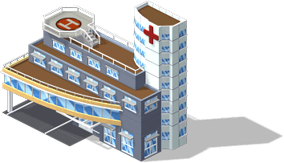**2) Virtual Hospital**

**3) Gaming Arena**

**4) Red Chillies International Bank**

**5) Exhibition Centre**

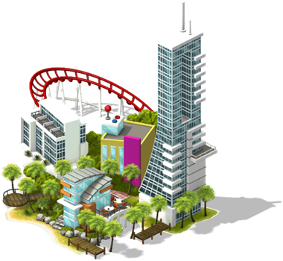

**Files Used:**

1. **Acnnpsd.txt**
2. 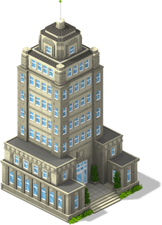**ACPASS.txt**
3. **DepositMoney.txt**
4. **DepositMoney2.txt**
5. **Loan.txt**

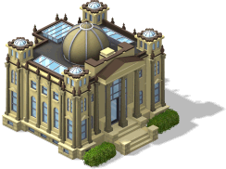

1. **City Description:**

**The Smart City is a multipurpose city, with a Gaming Arena, Hospital, Hotel and much more. The following describes the features in each building:**



1. **The Atlantis Hotel:**

It is a hotel which can accommodate people into different types of luxurious rooms such as Guest Rooms, Presidential Suites, Royale Suites etc. based on their standard and taste of living.

It tries to accommodate Guests with all the facilities and leaves no area for complaints. It gives a wide range of entertainment and joyful experiences at Events, Kids and Teens Section, Restaurants.

Even the biggest and fanciest of the Hotels round the world fail to lead The Atlantis.

1. **The Virtual Hospital:**

It is the health center of The Smart City. For those who are not well, the hospital examines the signs and issues of the patient, and recommends medicines. It also provides a full report containing all the details of the patient like Height, BMI, etc**.**



1. **Red Chillies International Bank:**

It is an International Bank, which offers a wide range of banking products and financial services. It is possible to create a New Account, Deposit and Withdraw money, and apply for Loans. There is an in-built Currency Exchange Centre, and a fully-furnished Waiting Room.

1. **Exhibition Centre:**

**An exhibition is going on in the Exhibition Centre. Here, the theme is Logic Gates. You can get to know about Logic Gates and also,**

**there is a Logic Circuit Designer, where you enter the expression and the Logic Circuit is displayed.**



1. **Gaming Arena:**

**It’s a place to take a break! There are a couple of games to play in the Gaming Arena, including the highly addicting game, 2048 and a Memory Tile game.**

1. **Modules Used:**

**1) pygame**

**2) os**

**3) time**

**4) sys**

**5) random**

1. **Hardware and Software Requirements:**

**1) Windows 2000 to Windows 7**

**2) 32-bit or 64-bit operating system**

**3) Minimum 256 MB RAM**

**4) Python Version 2.7**

**5) Keyboard, mouse, and monitor**

**6) Minimum Pentium 4, 1GHz single core**

1. **Program Code:**

import pygame,sys

import os,random,time

from pygame.locals import *

x_coord=0

y_coord=0

pygame.init()

bankvid=["TOIAD.mpg","HNYTrailer.mpg"]

pygame.mixer.pre_init(44100, -16, 2, 2048)

tracks=['CountingStars.wav','TurnUpTheSpeakers.wav','CallMeASpaceman.wav','Parachute.wav','Beam.wav','RightHere.wav']

for i in range(len(tracks)):

pygame.mixer.music.load(tracks[i])

pygame.mixer.music.play(0)

pygame.mixer.music.queue(tracks[i-1])

pygame.mixer.music.play(0)

def Video(x):

FPS = 60

pygame.init()

clock = pygame.time.Clock()

pygame.mixer.quit()

movie = pygame.movie.Movie(x)

movie.set_volume(1)

screen = pygame.display.set_mode(movie.get_size())

movie_screen = pygame.Surface(movie.get_size()).convert()

movie.set_display(movie_screen)

movie.play()

playing = True

while playing:

for event in pygame.event.get():

key=pygame.key.get_pressed()

if key[pygame.K_RETURN]:

movie.stop()

if x in bankvid:

Bank()

else:

Hotel()

screen.blit(movie_screen,(0,0))

pygame.display.update()

clock.tick(FPS)

pygame.quit()

def LogicGateDesigner():

print " LOGIC GATE EXHIBITION"

m=raw_input("In electronics, a logic gate is an idealized or physical device implementing a Boolean function; that is, it performs a logical operation on one or more logical inputs, and produces a single logical output.")

m=raw_input("Depending on the context, the term may refer to an ideal logic gate, one that has for instance zero rise time and unlimited fan-out, or it may refer to a non-ideal physical device")

m=raw_input("Logic gates are primarily implemented using diodes or transistors acting as electronic switches, but can also be constructed using electromagnetic relays (relay logic), fluidic logic, pneumatic logic, optics, molecules, or even mechanical elements.")

m=raw_input("With amplification, logic gates can be cascaded in the same way that Boolean functions can be composed, allowing the construction of a physical model of all of Boolean logic, and therefore, all of the algorithms and mathematics that can be described with Boolean logic.")

print

print

AND1=" ____"

AND2='---| \ '

AND3=" | )---"

ANDNOT=" | )o---"

AND4="---|____/"

OR1=" ______"

OR2=" ---\ \ "

OR3=" ) )---"

ORNOT=" ) )o---"

OR4=" ---/_____/"

NOT1=" |\ "

NOT2=" | \ "

NOT3="---| o---"

NOT4=" | /"

NOT5=" |/"

print

print "Here are some of the Gates that are used in Logic Circuits:"

print

print "AND Gate:"

print

print AND1

print AND2

print AND3

print AND4

print

print "OR Gate:"

print

print OR1

print OR2

print OR3

print OR4

print

print "NOT Gate:"

print

print NOT1

print NOT2

print NOT3

print NOT4

print NOT5

print

print "Welcome to the Logic Gate Designer!"

print

c=raw_input("Enter to continue(y/n)")

while c.lower()=='y':

exp=raw_input("Enter expression(Maximum 3 variables)")

m=len(exp)

for i in range(m):

if m<=4:

if exp[i]=='+':

if exp[-1]=="'":

print #A+B'

print exp[i-1]+"---------------"

print " | "+OR1[2:]

print " ",NOT1," "+" |-"+OR2[2:]

print " ",NOT2," "+OR3,exp

print exp[i+1],NOT3+"------"+OR4[2:]

print " ",NOT4

print " ",NOT5

else:

print " ",OR1 #A+B

print exp[i-1],OR2

print " ",OR3,exp

print exp[i+1],OR4

if exp[i]=='.':

if exp[-1]=="'":

print #A.B'

print exp[i-1]+"---------------"

print " | "+AND1[2:]

print " ",NOT1," "+" |-"+AND2[2:]

print " ",NOT2," "+AND3,exp

print exp[i+1],NOT3+"------"+AND4[2:]

print " ",NOT4

print " ",NOT5

else:

print " ",AND1 #A.B

print exp[i-1],AND2

print " ",AND3,exp

print exp[i+1],AND4

if m>4:

if exp[i]=='(':

if exp[i-1]=='.':

if exp[i+2]=='.':

if exp[-1]==')': #A.(B.C)

print " ",AND1

print exp[i-2],AND2

print exp[i+1],"---"+AND3[3:],exp

print exp[i+3],AND4

if exp[-1]=="'":

print #A.(B.C)'

print exp[i-2]+"---------------"

print " |"+AND1[2:]

print " ",AND1," "+" |"+AND2[2:]

print exp[i+1],AND2," "+AND3,exp

print " ",ANDNOT+"-"+AND4[2:]

print exp[i+3],AND4

if exp[i+2]=='+':

if exp[-1]==")":

print #A.(B+C)

print exp[i-2]+"-----------------"

print " |"+AND1[2:]

print " ",OR1," "+"|"+AND2[2:]

print exp[i+1],OR2," "+AND3,exp

print " ",OR3+"-"+AND4[2:]

print exp[i+3],OR4

if exp[-1]=="'":

print #A.(B+C)'

print exp[i-2]+"-----------------"

print " |"+AND1[2:]

print " ",OR1," "+"|"+AND2[2:]

print exp[i+1],OR2," "+AND3,exp

print " ",ORNOT+AND4[2:]

print exp[i+3],OR4

if exp[i-1]=="+":

if exp[i+2]=='+':

if exp[-1]==')':

print " ",OR1 #A+(B+C)

print exp[i-2],OR2

print exp[i+1],"-----"+OR3[5:],exp

print exp[i+3],OR4

if exp[-1]=="'":

print #A+(B+C)'

print exp[i-2]+"---------------"

print " | "+OR1[2:]

print " ",OR1," "+" |---"+OR2[2:]

print exp[i+1],OR2," "+OR3,exp

print " ",ORNOT+"-"+OR4[2:]

print exp[i+3],OR4

if exp[i+2]=='.':

if exp[-1]==')':

print #A+(B.C)

print exp[i-2]+"---------------"

print " |"+OR1[2:]

print " ",AND1," "+"|"+OR2[2:]

print exp[i+1],AND2," "+OR3,exp

print " ",AND3+"-"+OR4[2:]

print exp[i+3],AND4

if exp[-1]=="'":

print #A+(B.C)'

print exp[i-2]+"---------------"

print " |"+OR1[2:]

print " ",AND1," "+" |"+OR2[2:]

print exp[i+1],AND2," "+OR3,exp

print " ",ANDNOT+"-"+OR4[2:]

print exp[i+3],AND4

c=raw_input("Do you want to continue(y/n)")

else:

x_coord=500

y_coord=500

def VirtualHospital():

medicine1=['Tramadol','OxyContin','Aspirin','Brufen','Ketoprofen']

medicine2=['Dolophine','Azithromycin','Metronidazole','Erythromycin','Tetracycline']

doctor=['Dr. Mahesh','Dr. Sarah','Dr. Sumi','Dr. Raj Malhotra','Dr. Radhika']

import random

print "Health Check Up program!"

q=raw_input("Do you want to register in this program?")

x_coord1=0

y_ccord1=0

if q=='y':

width,height=443,450

screen1=pygame.display.set_mode((width,height))

pygame.display.set_caption('Receptionist')

background=pygame.image.load("Receptionist1.jpg")

screen1.blit(background,(0,0))

while True:

for event in pygame.event.get():

if event.type == pygame.QUIT:

pygame.quit()

if event.type == pygame.MOUSEBUTTONDOWN:

pos=pygame.mouse.get_pos()

x_coord=pos[0]

y_coord=pos[1]

pygame.display.flip()

break

m=raw_input("Okay! Hold on a minute!...")

pygame.display.set_caption('Receptionist')

background=pygame.image.load("Receptionist2.jpg")

screen1.blit(background,(0,0))

while True:

for event in pygame.event.get():

if event.type == pygame.QUIT:

pygame.quit()

if event.type == pygame.MOUSEBUTTONDOWN:

pos=pygame.mouse.get_pos()

x_coord=pos[0]

y_coord=pos[1]

pygame.display.flip()

break

name=raw_input("Your name please?")

print "Okay! Before everything, let's know your age and basic dimensions! :)"

pygame.display.set_caption('Receptionist')

background=pygame.image.load("Receptionist3.jpg")

screen1.blit(background,(0,0))

while True:

for event in pygame.event.get():

if event.type == pygame.QUIT:

pygame.quit()

if event.type == pygame.MOUSEBUTTONDOWN:

pos=pygame.mouse.get_pos()

x_coord=pos[0]

y_coord=pos[1]

break

pygame.display.flip()

break

age=input("Enter your age please!")

height=input("Tell me your height please!(cms)")

weight=input("And tell me your weight please!(kgs)")

print "Hmmm..that's not bad..Now let's Calculate your BMI.. ;)"

Q=raw_input("Calculating your BMI...")

bmi=weight*10000/height**2

print "And Yeah...Your BMI is",bmi

if bmi<18.5:

print "You are slightly underweight, why don't you try eating a little more and do a bit more of Body building and exercise? :)"

width,height=443,450

screen1=pygame.display.set_mode((width,height))

pygame.display.set_caption('Receptionist')

background=pygame.image.load("Receptionist4.jpg")

screen1.blit(background,(0,0))

while True:

for event in pygame.event.get():

if event.type == pygame.QUIT:

pygame.quit()

if event.type == pygame.MOUSEBUTTONDOWN:

pos=pygame.mouse.get_pos()

x_coord=pos[0]

y_coord=pos[1]

break

pygame.display.flip()

break

if 18.5<=bmi<=25:

print "You have optimal weight. Congratulations! Keep it up!"

width,height=443,450

screen1=pygame.display.set_mode((width,height))

pygame.display.set_caption('Receptionist')

background=pygame.image.load("Receptionist5.jpg")

screen1.blit(background,(0,0))

while True:

for event in pygame.event.get():

if event.type == pygame.QUIT:

pygame.quit()

if event.type == pygame.MOUSEBUTTONDOWN:

pos=pygame.mouse.get_pos()

x_coord=pos[0]

y_coord=pos[1]

break

pygame.display.flip()

break

if bmi>25:

width,height=443,450

screen1=pygame.display.set_mode((width,height))

pygame.display.set_caption('Receptionist')

background=pygame.image.load("Receptionist6.jpg")

screen1.blit(background,(0,0))

print "You are slightly overweight, You should avoid taking heavy amounts of food. Restrict your food upto 2400 calories per day. Take diets often and do a little more of exercise! :)"

while True:

for event in pygame.event.get():

if event.type == pygame.QUIT:

pygame.quit()

if event.type == pygame.MOUSEBUTTONDOWN:

pos=pygame.mouse.get_pos()

x_coord=pos[0]

y_coord=pos[1]

break

pygame.display.flip()

break

print

print

print

width,height=443,450

screen1=pygame.display.set_mode((width,height))

pygame.display.set_caption('Receptionist')

background=pygame.image.load("Receptionist7.jpg")

screen1.blit(background,(0,0))

Q=raw_input("Okay let's proceed onto your health check up!")

while True:

for event in pygame.event.get():

if event.type == pygame.QUIT:

pygame.quit()

if event.type == pygame.MOUSEBUTTONDOWN:

pos=pygame.mouse.get_pos()

x_coord=pos[0]

y_coord=pos[1]

break

pygame.display.flip()

break

c=random.randint(1000,2000)

print "Your register number is",c

print

m=random.randint(0,3)

n=random.randint(1,100)

print

Q=raw_input("Now please proceed to the reception :)")

print "*"*80

print

print " RECEPTION"

print

print "*"*80

regno=input("Receptionist : Hello! Please could you let me know your registration number?")

if regno==c:

print "Okay! Your doctor will be",doctor[m],".Please proceed to room no. R",n,":)"

else:

print "Sorry that number doesnt exist....But I think you just registered as",c,"Your doctor will be",doctor[m],".Please proceed to room no. R",n,":)"

Q=raw_input()

print

print "Doctor: Hello There! Mr.",name,"!"

q1=raw_input("So...how are you feeling?")

Q=raw_input("Doctor: I see...Do you have any allergies or addictions?(y/n)")

if Q=='y':

prob=raw_input("Doctor: May I know what is it?")

global b

b=prob

print "I see...alright I'm prescribing a medicine for this, Please visit the pharmacy for the medicine"

if Q=='n':

q=raw_input("And do you have any other health problems?(y/n)")

if q=='y':

global b

b=raw_input("May I know it please?")

print "Okay, I'm prescribing a medicine for this,Please visit the pharmacy for the medicine"

M=raw_input()

if q=='n':

print "You seem to be quite healthy! Keep this up!"

print

b='-'

if bmi>25:

print "But please avoid taking heavy amounts of food. Restrict your food upto 2400 calories per day and take diets often since your BMI shows that you are overweight"

if bmi<18.5:

print "But please try eating a little more and do a bit more of Body builing and exercise since your BMI shows that you are underweight"

M=raw_input()

print

print "*"*80

print

print " PHARMACY"

print

print "*"*80

print

regno=raw_input("Hello! May I know your register number please..")

print "Okay Mr.",name,",",doctor[m],"has just prescribed a medicine for you!"

Q=raw_input()

print "Here's your overall report!"

print

print "*"*80

print " PYTHON ONLINE HOSPITAL"

print " - Your health is just a click away!"

print

print " Name:",name

print " Age:",age

print " Weight:",weight,"kgs"

print " Height:",height,"cms"

print " BMI:",bmi

print " Problem:",b

print " Medicine:",

if b=="-":

print "Brufen (Antibiotic) - 2 times a day"

else:

print " 1)",medicine1[random.randint(0,4)],random.randint(2,4),"times a day"

print " 2)",medicine2[random.randint(0,4)],random.randint(2,4),"times a day"

print

print " Thank You! Visit Again!"

print

print "*"*80

def Hotel():

import pygame,time,sys

global x_coord, y_coord

pygame.init()

x_coord=0

y_coord=0

screen=pygame.display.set_mode((1200,593))

pygame.display.set_caption('Where Water Meets Wonder - Atlantis')

a=pygame.image.load("Hotel1.jpg")

screen.blit(a,(0,0))

print "Welcome to Atlantis"

print " "

print "Here at Atlantis, you will find each hotel room and suite is beautifully designed with subtle oceanic influences, complete with spectacular views of the azure waters of the Arabian Sea, or across our beach and over the iconic Palm and magnificent Dubai skyline. 90% of our hotel rooms and suites are interconnecting, making Atlantis the perfect choice for a family friendly holiday in Dubai.\n"

print "The wonder of water breathes life into each spectacular Atlantis hotel room and suite. Unreservedly spacious, each room is designed to immerse Atlantis guests in absolute comfort and unparalleled luxury.\n"

print "Guest hotel rooms comfortably accommodate two adults and two children together. Enjoy the spectacular vistas from your spacious balcony and relax in your surroundings featuring walk-in wardrobes, beautiful bathrooms and 24hour in-room dining to cater to every taste.\n"

while True:

for event in pygame.event.get():

if event.type == pygame.QUIT:

pygame.quit()

if event.type == pygame.MOUSEBUTTONDOWN:

pos=pygame.mouse.get_pos()

x_coord=pos[0]

y_coord=pos[1]

if x_coord in range(0,1200) and y_coord in range(0,530):

screen = pygame.display.set_mode([933,526])

a=pygame.image.load("Hotel.png")

screen.blit(a,(0,0))

for event in pygame.event.get():

if event.type == pygame.QUIT:

pygame.quit()

if event.type == pygame.MOUSEBUTTONDOWN:

pos=pygame.mouse.get_pos()

x_coord=pos[0]

y_coord=pos[1]

if x_coord in range(35,448) and y_coord in range(68,117):

#Rooms

screen = pygame.display.set_mode([962,541])

a=pygame.image.load("Rooms.png")

screen.blit(a,(0,0))

for event in pygame.event.get():

if event.type == pygame.QUIT:

pygame.quit()

if event.type == pygame.MOUSEBUTTONDOWN:

pos=pygame.mouse.get_pos()

x_coord=pos[0]

y_coord=pos[1]

if x_coord in range(26,455) and y_coord in range(75,125):

#Guest Room

loop=1

ch=0

while loop==1:

print " "

print "Guest Room Amenities \n"

print "Guest Room benefits include:"

print "Unlimited complimentary access to Aquaventure Waterpark and The Lost Chambers Aquarium"

print "1 free complimentary afternoon session at Kids Club or Club Rush"

print "Option of king or double queen beds (subject to availability)"

print "Balcony in king size bedrooms and French balcony in double queen rooms"

print "Complimentary bathroom amenities"

print "Walk in shower and separate bath"

print "Cable / Satellite TV"

print "24 hour room service"

print "Complimentary tea and coffee making facilities"

print "Comfortable sitting area"

print "90% interconnecting rooms"

print "FREE WIFI access"

print "Mini Bar\n"

print "Guest Room Occupancy"

print "Maximum Occupancy:"

print "2 adults + 2 children below 12 years of age or 3 adults or 3 adults + 1 child below 12 years of age\n"

print "Additional Information:"

print "Surcharge for extra bedding"

print " "

print "There are Three types of Guest Rooms,"

print "1. Deluxe"

print "2. Ocean Deluxe"

print "3. Palm Beach Deluxe"

print "4. Quit\n"

ch=input("Enter Your Choice:")

if ch==1:

#Deluxe

print "You have Chosen to see Deluxe Room,"

screen = pygame.display.set_mode([800,500])

a=pygame.image.load("CollageDL.jpg")

screen.blit(a,(0,0))

while True:

for event in pygame.event.get():

if event.type == pygame.QUIT:

pygame.quit()

if event.type == pygame.MOUSEBUTTONDOWN:

pos=pygame.mouse.get_pos()

x_coord=pos[0]

y_coord=pos[1]

break

pygame.display.flip()

break

a=raw_input("Do you wish to opt this Room(Y/N):")

if a=='y' or a=='Y':

print "Thank you for making this Choice"

print "This Room Prices are at a all time Low Now"

name=raw_input("Please Enter Your Name:")

adults=input("How many Adult(s):")

child=input("How many Children:")

if (adults==3 and child==0) or (adults==2 and child==2) or (adults==3 and child==1)or(adults==1 and child==0):

n=input("How many Days would you be staying:")

print "The Price of your stay sums up to(Dollars):AED",400*n

bank=raw_input("Which Bank's Account Holder are you:")

acn=raw_input("Please Enter your Account Number:")

scp=input("Security Pin:")

print "Hit enter to Save your Details"

a=raw_input()

print "Your Room Number is,",random.randint(1,1500),"on floor",random.randint(1,100)

else:

print "Invalid No. of Adults and Childrens"

print "Please refer to the Rules Again"

a=input()

adults=input("How many Adult(s):")

child=input("How many Children:")

if (adults==3 and child==0) or (adults==2 and child==2) or (adults==3 and child==1) or(adults==1 and child==0):

n=input("How many Days would you be staying:")

print "The Price of your stay sums up to(Dollars):$",400*n

bank=raw_input("Which Bank's Account Holder are you:")

acn=raw_input("Please Enter your Account Number:")

scp=input("Security Pin:")

print "Hit enter to Save your Details"

a=input()

print "Your Room Number is,",random.randint(1,1500),"on floor",random.randint(1,100)

else:

print "Invalid Again, Try Later"

else:

print "You Can Move on with other Options"

break

if ch==2:

#Ocean Deluxe

print "You have Chosen to see Ocean Deluxe Room,"

screen = pygame.display.set_mode([800,500])

a=pygame.image.load("CollageOD.jpg")

screen.blit(a,(0,0))

while True:

for event in pygame.event.get():

if event.type == pygame.QUIT:

pygame.quit()

if event.type == pygame.MOUSEBUTTONDOWN:

pos=pygame.mouse.get_pos()

x_coord=pos[0]

y_coord=pos[1]

break

pygame.display.flip()

break

a=raw_input("Do you wish to opt this Room(Y/N):")

if a=='y' or a=='Y':

print "Thank you for making this Choice"

print "This Room Prices are at a all time Low Now"

name=raw_input("Please Enter Your Name:")

adults=input("How many Adult(s):")

child=input("How many Children:")

if (adults==3 and child==0) or (adults==2 and child==2) or (adults==3 and child==1) or (adults==1 and child==0):

n=input("How many Days would you be staying:")

print "The Price of your stay sums up to(Dollars):AED",450*n

bank=raw_input("Which Bank's Account Holder are you:")

acn=raw_input("Please Enter your Account Number:")

scp=input("Security Pin:")

print "Hit enter to Save your Details"

a=raw_input()

print "Your Room Number is,",random.randint(1,1500),"on floor",random.randint(1,100)

else:

print "Invalid No. of Adults and Childrens"

print "Please refer to the Rules Again"

a=input()

adults=input("How many Adult(s):")

child=input("How many Children:")

if (adults==3 and child==0) or (adults==2 and child==2) or (adults==3 and child==1) or (adults==1 and child==0):

n=input("How many Days would you be staying:")

print "The Price of your stay sums up to(Dollars):$",400*n

bank=raw_input("Which Bank's Account Holder are you:")

acn=raw_input("Please Enter your Account Number:")

scp=input("Security Pin:")

print "Hit enter to Save your Details"

a=input()

print "Your Room Number is,",random.randint(1,1500),"on floor",random.randint(1,100)

else:

print "Invalid Again, Try Later"

else:

print "You Can Move on with other Options"

break

if ch==3:

#Palm Beach Deluxe

print "You have Chosen to see Palm Beach Deluxe Room,"

screen = pygame.display.set_mode([800,500])

a=pygame.image.load("CollagePBD.jpg")

screen.blit(a,(0,0))

while True:

for event in pygame.event.get():

if event.type == pygame.QUIT:

pygame.quit()

if event.type == pygame.MOUSEBUTTONDOWN:

pos=pygame.mouse.get_pos()

x_coord=pos[0]

y_coord=pos[1]

break

pygame.display.flip()

break

a=raw_input("Do you wish to opt this Room(Y/N):")

if a=='y' or a=='Y':

print "Thank you for making this Choice"

print "This Room Prices are at a all time Low Now"

name=raw_input("Please Enter Your Name:")

adults=input("How many Adult(s):")

child=input("How many Children:")

if (adults==3 and child==0) or (adults==2 and child==2) or (adults==3 and child==1) or (adults==1 and child==0):

n=input("How many Days would you be staying:")

print "The Price of your stay sums up to(Dollars):AED",500*n

bank=raw_input("Which Bank's Account Holder are you:")

acn=raw_input("Please Enter your Account Number:")

scp=input("Security Pin:")

print "Hit enter to Save your Details"

a=raw_input()

print "Your Room Number is,",random.randint(1,1500),"on floor",random.randint(1,100)

else:

print "Invalid No. of Adults and Childrens"

print "Please refer to the Rules Again"

a=input()

adults=input("How many Adult(s):")

child=input("How many Children:")

if (adults==3 and child==0) or (adults==2 and child==2) or (adults==3 and child==1) or (adults==1 and child==0):

n=input("How many Days would you be staying:")

print "The Price of your stay sums up to(Dollars):$",400*n

bank=raw_input("Which Bank's Account Holder are you:")

acn=raw_input("Please Enter your Account Number:")

scp=input("Security Pin:")

print "Hit enter to Save your Details"

a=input()

print "Your Room Number is,",random.randint(1,1500),"on floor",random.randint(1,100)

else:

print "Invalid Again, Try Later"

else:

print "You Can Move on with other Options"

break

elif ch==4:

x_coord=500

y_coord=500

break

if x_coord in range(510,940) and y_coord in range(75,125):

#Imperial Club

screen = pygame.display.set_mode((800,500))

a=pygame.image.load("CollageIC.jpg")

screen.blit(a,(0,0))

while True:

for event in pygame.event.get():

if event.type == pygame.QUIT:

pygame.quit()

if event.type == pygame.MOUSEBUTTONDOWN:

pos=pygame.mouse.get_pos()

x_coord=pos[0]

y_coord=pos[1]

break

pygame.display.flip()

break

print "You have selected to see the Imperial Club Lounge and Rooms."

print "The perfect choice for guests seeking additional luxury and comfort plus extra benefits worth over AED 3,000 per day\n"

print "Imperial Club is the perfect choice for guests seeking additional luxury, comfort and convenience. The Imperial Club Lounge is exclusively available to guests staying in Imperial Club rooms.\n"

print "What makes Imperial Club really special is all the added value benefits including complimentary full hot breakfast, all day snacks, afternoon tea and pre-dinner cocktails/canapes and complimentary\n"

print "access to the PressReader app on your personal device, allowing you to read newspapers and magzines from over 100 countries.\n"

print "Families with children between the ages of 3 and 12 years will also benefit from daily complimentary access to Kids Club between 10:00am - 06:00pm and a play area in the lounge itself."

print "Imperial Club Amenities and Benefits\n"

print "Imperial Club lounges are accessible from 7:00AM to 11:00PM daily.\n"

print "Breakfast is available in one of our lounges or Saffron or Kaleidoscope restaurants from 7:00AM to 11:00AM daily.\n"

print "24 hour In-Room Dining is available and will be charged to your room bill at the rates detailed on the menu.\n"

print "Afternoon tea is available in one of our Imperial Club lounges from 2:30PM to 4:30PM daily.\n"

print "A selection of complimentary beverages and canaps are served in our lounges from 5:00PM to 7:00PM daily.\n"

print "Light sweet and savoury snacks are available throughout the day including juice, tea, coffee and complimentary soft drinks in our lounges.\n"

print "Complimentary daily access to Kids Club for children 3 - 9 years of age from 10:00AM - 6:00PM (lunchtime meals are charged between 1:00PM - 2:00PM and no activities will take place during this time).\n"

print "Complimentary daily access to either Kids Club or Club Rush for children aged 10 - 12 years at allotted times.\n"

print "Complimentary daily access to Club Rush for teens 13 - 17 years of age from 2:00PM - 6:00PM.\n"

print "Complimentary N'Dulge nightclub access (excluding certain separately ticketed events).\n"

print "Dedicated high speed Internet is available to Imperial Club guests complimentary.\n"

print "Complimentary use of iPads are available to Imperial Club guests in the lounges.\n"

print "Complimentary access to over 2,000+ newspapers and 100 magazines from 100 countries in 56 languages using Pressreader.com during your stay in our resort.\n"

print "Complimentary use of the steam, sauna and jet pool facilities at ShuiQi Spa.\n"

print "2 ShuiQi Spa Treatments for the price of 1 (Back, Neck & Shoulder 30 minutes massage).\n"

print "Priority Bellman Services."

print "Please present your Imperial Club Access Card to the pool attendant to ensure that the team takes special care of your needs.\n"

print "Dress Code: Smart casual / Smart shorts / Cover-ups and no wet clothes\n"

print "Imperial Club Room Occupancy\n"

print "Maximum Occupancy:\n"

print "2 adults + 2 children below 12 years of age or 3 adults or 3 adults + 1 child below 12 years of age.\n"

print "Additional Information:\n"

print "Surcharge for extra bedding\n"

a=raw_input("Do you wish to opt this Room(Y/N):")

if a=='y' or a=='Y':

print "Thank you for making this Choice"

print "This Room Prices are at a all time Low Now"

name=raw_input("Please Enter Your Name:")

adults=input("How many Adult(s):")

child=input("How many Children:")

if (adults==3 and child==0) or (adults==2 and child==2) or (adults==3 and child==1):

n=input("How many Days would you be staying:")

print "The Price of your stay sums up to(Dollars):AED",500*n

bank=raw_input("Which Bank's Account Holder are you:")

acn=raw_input("Please Enter your Account Number:")

scp=input("Security Pin:")

print "Hit enter to Save your Details"

a=raw_input()

print "Your Room Number is,",random.randint(1,1500),"on floor",random.randint(1,100)

else:

print "Invalid No. of Adults and Childrens"

print "Please refer to the Rules Again"

a=input()

adults=input("How many Adult(s):")

child=input("How many Children:")

if (adults==3 and child==0) or (adults==2 and child==2) or (adults==3 and child==1):

n=input("How many Days would you be staying:")

print "The Price of your stay sums up to(Dollars):$",400*n

bank=raw_input("Which Bank's Account Holder are you:")

acn=raw_input("Please Enter your Account Number:")

scp=input("Security Pin:")

print "Hit enter to Save your Details"

a=input()

print "Your Room Number is,",random.randint(1,1500),"on floor",random.randint(1,100)

else:

print "Invalid Again, Try Later"

else:

print "You Can Move on with other Options"

x_coord=500

y_coord=500

break

if x_coord in range(270,700) and y_coord in range(350,400):

#Royale Suites

print "*"*75

print "You have chosen the Best-Available Room of our Hotel"

print "Hope,it matches your Standards and provides you pleasure"

print "At 924 square metres the Royal Bridge Suite is truly palatial."

print "One- of- a- kind it majestically spans the arch which links the Royal Towers offering un-paralleled"

print "180 degree views of The Palm and the Arabian Sea."

print "The Royal Bridge Suite is the only choice for if you are seeking the ultimate in privacy and luxury."

print "It has its own guarded entrance and elevator along with a dedicated team of people from Butlers to"

print "Chefs on hand to ensure that your every need is fulfilled."

print "The decor is exquisite and opulent reflecting the stature of the suite. With 3 sumptuous bedrooms,"

print "a grand living room, a dining room which seats 16, a majilis and two spacious terraces The Royal Bridge"

print "Suite offers you the perfect haven in which to relax or entertain."

print "*"*75

screen3 = pygame.display.set_mode([800,500])

a3=pygame.image.load("CollageRS.jpg")

screen3.blit(a3,(0,0))

while True:

for event in pygame.event.get():

if event.type == pygame.QUIT:

pygame.quit()

if event.type == pygame.MOUSEBUTTONDOWN:

pos=pygame.mouse.get_pos()

x_coord=pos[0]

y_coord=pos[1]

pygame.display.flip()

break

a=raw_input("Do you wish to opt this Room(Y/N):")

if a=='y' or a=='Y':

print "Thank you for making this Choice"

print "This Room Prices are at a all time Low Now"

name=raw_input("Please Enter Your Name:")

adults=input("How many Adult(s):")

child=input("How many Children:")

n=input("How many Days would you be staying:")

print "The Price of your stay sums up to(Dollars):$",1500*n

bank=raw_input("Which Bank's Account Holder are you:")

acn=raw_input("Please Enter your Account Number:")

scp=input("Security Pin:")

print "Hit enter to Save your Details"

a=raw_input()

print "Your Room Number is,",random.randint(1450,1500),"on floor 95."

y=raw_input("Do you wish to watch a Video?((Y/N):")

y=y.lower()

if y=='y':

Video('Royale.mpg')

else:

print "You Can Move on with other Options"

x_coord=500

y_coord=500

if x_coord in range(26,455) and y_coord in range(440,495):

#Signature Suites

print "There are three types,"

print "1. Presidential"

print "2. Underwater"

print "3. Grand Atlantis"

print "4. Quit\n"

ch=input("Which Room Would you like to see?:")

if ch==1:

#Presidential

print "*"*75

print "You have chosen to see Presidenial Rooms"

print "For the perfect balance of luxury and comfort book one of our Presidential Suites complete with a dedicated butler on hand 24/7"

print "to meet all your needs. With a separate bedroom with king size bed, a large living area including a dining table for 8 and an"

print "interconnecting room the Presidential Suite is an ideal option for larger families\n"

print "*"*75

screen4 = pygame.display.set_mode([800,500])

a4=pygame.image.load("CollagePR.jpg")

screen4.blit(a4,(0,0))

while True:

for event in pygame.event.get():

if event.type == pygame.QUIT:

pygame.quit()

if event.type == pygame.MOUSEBUTTONDOWN:

pos=pygame.mouse.get_pos()

x_coord=pos[0]

y_coord=pos[1]

pygame.display.flip()

break

print "Do you wish to opt this Room?(Y/N):"

pr=raw_input()

if pr=='Y' or pr=='y':

print "Thank you for making this Choice"

print "This Room Prices are at a all time Low Now"

name=raw_input("Please Enter Your Name:")

adults=input("How many Adult(s):")

child=input("How many Children:")

n=input("How many Days would you be staying:")

print "The Price of your stay sums up to(Dollars):$",900*n

bank=raw_input("Which Bank's Account Holder are you:")

acn=raw_input("Please Enter your Account Number:")

scp=input("Security Pin:")

print "Hit enter to Save your Details"

a=raw_input()

print "Your Room Number is,",random.randint(750,1050),"on floor",random.randint(80,95)

else:

print "Thank You, You can now move ahead"

x_coord=500

y_coord=500

if ch==2:

#Underwater

print "*"*75

print "You have chosen to see Underwater Rooms"

print "If you are looking for the most intimate and romantic setting for your holiday look no further than our Underwater Suites; Poseidon and Neptune."

print "When you arrive at your suite you will literally descend into the perfect hide-away. Elegant aquatic-themed accommodation includes a large living area complete with dining table, a separate majlis/ TV room,"

print "a beautifully appointed bedroom and ensuite bathroom."

print "However it is the view from the bedroom and bathroom that will blow you away. With floor to ceiling windows into Ambassador Lagoon,"

print "we guarantee that you will be captivated by the dramatic ancient ruins of the mythical lost city and its 65,000 marine inhabitants."

print "This is the ultimate romantic getaway complete with a dedicated butler on hand 24/7 to meet all your requests."

print "*"*75

screen4 = pygame.display.set_mode([800,500])

a4=pygame.image.load("CollageUR.jpg")

screen4.blit(a4,(0,0))

while True:

for event in pygame.event.get():

if event.type == pygame.QUIT:

pygame.quit()

if event.type == pygame.MOUSEBUTTONDOWN:

pos=pygame.mouse.get_pos()

x_coord=pos[0]

y_coord=pos[1]

pygame.display.flip()

break

print "Do you wish to opt this Room?(Y/N):"

pr=raw_input()

if pr=='Y' or pr=='y':

print "Thank you for making this Choice"

print "This Room Prices are at a all time Low Now"

name=raw_input("Please Enter Your Name:")

adults=input("How many Adult(s):")

child=input("How many Children:")

n=input("How many Days would you be staying:")

print "The Price of your stay sums up to(Dollars):$",1000*n

bank=raw_input("Which Bank's Account Holder are you:")

acn=raw_input("Please Enter your Account Number:")

scp=input("Security Pin:")

print "Hit enter to Save your Details"

a=raw_input()

print "Your Room Number is,",random.randint(750,1050),"on floor",random.randint(55,65)

x=raw_input("Do you wish to watch a Video?(Y/N):")

x=x.lower()

if x=='y':

Video('Underwater Suite.mpg')

x_coord=500

y_coord=500

else:

print "Thank You, You can now move ahead"

x_coord=500

y_coord=500

if ch==3:

#Grand Atlantis

print "*"*75

print "You have chosen to see Grand Atlantis Rooms"

print "If al fresco living is your thing the Grand Atlantis Suite offers a spectacular sun terrace which spans three sides of the suite."

print "The entire suite is decorated in elegant gold tones which exude luxury and opulence. The lavish living space includes a master bedroom,"

print "complete with his and hers bathrooms, a guest bedroom with an ensuite bathroom, a living room with a dining table for 10 and a separate office."

print "Grand by name and grand by nature this Suite is guaranteed to impress."

print "*"*75

screen4 = pygame.display.set_mode([800,500])

a4=pygame.image.load("CollageGR.jpg")

screen4.blit(a4,(0,0))

while True:

for event in pygame.event.get():

if event.type == pygame.QUIT:

pygame.quit()

if event.type == pygame.MOUSEBUTTONDOWN:

pos=pygame.mouse.get_pos()

x_coord=pos[0]

y_coord=pos[1]

pygame.display.flip()

break

print "Do you wish to opt this Room?(Y/N):"

pr=input()

if pr=='Y' or pr=='y':

print "Thank you for making this Choice"

print "This Room Prices are at a all time Low Now"

name=raw_input("Please Enter Your Name:")

adults=input("How many Adult(s):")

child=input("How many Children:")

n=input("How many Days would you be staying:")

print "The Price of your stay sums up to(Dollars):$",1100*n

bank=raw_input("Which Bank's Account Holder are you:")

acn=raw_input("Please Enter your Account Number:")

scp=input("Security Pin:")

print "Hit enter to Save your Details"

a=raw_input()

print "Your Room Number is,",random.randint(1050,1100),"on floor",random.randint(65,80)

else:

print "Thank You, You can now move ahead"

x_coord=500

y_coord=500

if x_coord in range(510,937) and y_coord in range(438,488):

#Concierge and Guest Service

print "*"*75

print "Our knowledgeable and friendly Concierges are delighted to help our guests in any way possible throughout their stay."

print "Our Services Include,"

print "1.Tours and Safari Reservations"

print "2.Big Bus Tours"

print "3.RTA Water Taxi Service"

print "4.First Yacht Charter"

print "5.Helicopter Services"

print "6.Luxury Limousine and Exotic Sports Car Fleet Rental"

print "7.Atlantis Chauffeur Services"

print "8.Dubai International Airport Transfers"

print "9.Travel Arrangements"

print "10.Shopping Information"

print "11.Nanny and Babysitting Service"

print "12.Special Moments"

print "*"*75

print "Hit Enter to Exit"

a=input()

print "Thank You, You can now move ahead"

x_coord=500

y_coord=500

if x_coord in range(35,448) and y_coord in range(150,190):

#Restaurants and Dining

print "*"*75

print "Home to some of the best restaurants in Dubai and brought to you by world renowned chefs, Atlantis is truly a culinary destination."

print "With 23 restaurants, bars and lounges serving over 28 different cuisines, we've got you covered, from family friendly options to fine dining experiences."

print "Although each restaurant is unique in menu and setting, all are founded on the commitment to provide the very best dining experience."

print "Whatever your taste or style, Atlantis has the restaurant to suit any occasion and palate, creating memories to last a lifetime."

print "*"*75

print "The following options are available,"

print "1.Restaurants and Bars"

print "2.Restaurant Experiences"

print "3.Quit"

print " "

ch=input("Enter Your Choice:")

if ch==1:

c5=0

loop5=0

#Restaurants and Bars

print "The following Restaurants house Atlantis,"

print "1.Ossiano"

print "2.Nobu"

print "3.Barazura"

print "4.Seafire Streakhouse and Bar"

print "5.Ronda Locatelli"

print "6.Nasimi Beach"

print "7.Levantine"

print "8.La Brasserie"

print "9.Saffron"

print "10.Waterpark Restaurants"

print "11.Plato's"

print "12.Asia Republic"

print "13.Quit"

while loop5==0:

c5=input("Enter Your Choice:")

if c5==1:

screen = pygame.display.set_mode([617,297])

a=pygame.image.load("Ossiano.jpg")

screen.blit(a,(0,0))

pygame.display.flip()

if c5==2:

screen = pygame.display.set_mode((617,297))

a=pygame.image.load("Nobu.jpg")

screen.blit(a,(0,0))

pygame.display.flip()

if c5==3:

screen = pygame.display.set_mode((640,300))

a=pygame.image.load("Barazura.png")

screen.blit(a,(0,0))

pygame.display.flip()

if c5==4:

screen = pygame.display.set_mode((617,297))

a=pygame.image.load("Seafire.jpg")

screen.blit(a,(0,0))

pygame.display.flip()

if c5==5:

screen = pygame.display.set_mode((617,297))

a=pygame.image.load("Ronda.jpg")

screen.blit(a,(0,0))

pygame.display.flip()

if c5==6:

screen = pygame.display.set_mode((800,400))

a=pygame.image.load("Nasimi.jpg")

screen.blit(a,(0,0))

pygame.display.flip()

if c5==7:

screen = pygame.display.set_mode((617,297))

a=pygame.image.load("Levantine.jpg")

screen.blit(a,(0,0))

pygame.display.flip()

if c5==8:

screen = pygame.display.set_mode((617,297))

a=pygame.image.load("Brasserie.jpg")

screen.blit(a,(0,0))

pygame.display.flip()

if c5==9:

screen = pygame.display.set_mode((617,297))

a=pygame.image.load("Saffron.jpg")

screen.blit(a,(0,0))

pygame.display.flip()

if c5==10:

screen = pygame.display.set_mode((615,374))

a=pygame.image.load("Waterpark.jpg")

screen.blit(a,(0,0))

pygame.display.flip()

if c5==11:

screen = pygame.display.set_mode((800,600))

a=pygame.image.load("Plato.jpg")

screen.blit(a,(0,0))

pygame.display.flip()

if c5==12:

screen = pygame.display.set_mode((1244,829))

a=pygame.image.load("Asia Republic.jpg")

screen.blit(a,(0,0))

pygame.display.flip()

if c5==13:

loop5=0

x_coord=500

y_coord=500

break

if ch==2:

#Restaurant Experiences

screen = pygame.display.set_mode((800,500))

a=pygame.image.load("Awards.jpg")

screen.blit(a,(0,0))

pygame.display.flip()

print "*"*50

print "Our Restaurant(s)' facilities include,"

print "1.Award Winning"

print "2.Fine Dining"

print "3.Family Restaurants"

print "4.Casual Dining"

print "5.Buffets"

print "6.Outdoor Dining"

print "7.Breakfasts and Afternoon Tea"

print "8.Coffee Shops and Snacks"

print "9.Friday Brunch"

print "10.Clubs, Bars and Lounges"

print "*"*50

x_coord=500

y_coord=500

if ch==3:

print "Thank You, You can now move ahead"

x_coord=500

y_coord=500

loop5=1

if x_coord in range(35,448) and y_coord in range(220,270):

#Marine and Waterpark

loop6=0

print "*"*50

print "Your Choices are,"

print "1.Dolphin Bay"

print "2.Sea Lion Point"

print "3.Aquaventure Waterpark"

print "4.The Lost Chambers Aqaurium"

print "5.Marine Animal Adventures"

print "6.Watch a Video and Quit"

print "*"*50

while loop6==0:

ch6=input("Enter Your Choice:")

if ch6==1:

screen = pygame.display.set_mode((1286,713))

a=pygame.image.load("DolphinBay.png")

screen.blit(a,(0,0))

pygame.display.flip()

if ch6==2:

screen = pygame.display.set_mode((800,500))

a=pygame.image.load("CollageSL.jpg")

screen.blit(a,(0,0))

pygame.display.flip()

if ch6==3:

screen = pygame.display.set_mode((1280,802))

a=pygame.image.load("Aquaventure.png")

screen.blit(a,(0,0))

pygame.display.flip()

if ch6==4:

screen = pygame.display.set_mode((1200,817))

a=pygame.image.load("Aquarium.jpg")

screen.blit(a,(0,0))

pygame.display.flip()

if ch6==5:

screen = pygame.display.set_mode((800,500))

a=pygame.image.load("CollageMA.jpg")

screen.blit(a,(0,0))

pygame.display.flip()

if ch6==6:

Video('Aquaventure.mpg')

loop6=0

x_coord=500

y_coord=500

break

if x_coord in range(35,448) and y_coord in range(300,340):

#Meetings and Events

print "*"*75

print "From the moment you arrive at our venue, it's clear that you are about to experience something out of the ordinary."

print "Flexible meeting room configurations provide the perfect set up for anything from an executive retreat in a private"

print "boardroom to a gala dinner for 1,500 in the glamorous Atlantis Ballroom."

print " "

print "Private breakout areas, separate lobby and Porte Cochere entrance ensure privacy for guests and organisers alike."

print "Finally, we have guaranteed availability of up to 600 rooms which makes Atlantis the largest eat, meet and sleep conference venue in Dubai."

print "*"*75

screen = pygame.display.set_mode((800,500))

a=pygame.image.load("CollageME.jpg")

screen.blit(a,(0,0))

pygame.display.flip()

b=raw_input("Hit Enter to Watch a Video")

Video('Fireworks.mpg')

x_coord=500

y_coord=500

if x_coord in range(35,448) and y_coord in range(380,420):

#Kids and Teens

print "*"*75

print "From surreal sea life to heart-pounding water slides, even our youngest guests are able to explore Atlantis"

print "and its deep connection to water and the ocean."

print "*"*75

screen = pygame.display.set_mode((800,500))

a=pygame.image.load("CollageKT.jpg")

screen.blit(a,(0,0))

pygame.display.flip()

x_coord=500

y_coord=500

if x_coord in range(205,280) and y_coord in range(430,500):

#Information

screen = pygame.display.set_mode((962,543))

a=pygame.image.load("Info.png")

screen.blit(a,(0,0))

pygame.display.flip()

x_coord=500

y_coord=500

if x_coord in range(819,888) and y_coord in range(438,504):

print "Thank you! Come again!"

Main()

pygame.display.flip()

def Bank():

import pygame,time, sys, ctypes

z=c=c1=0

pygame.init()

x_coord=0

y_coord=0

n=0

global staytime

staytime="0"

width,height=978,750

screen=pygame.display.set_mode((width,height))

pygame.display.set_caption('Red Chillies International Bank')

background=pygame.image.load("bank.png")

screen.blit(background,(0,0))

while True:

for event in pygame.event.get():

if event.type == pygame.QUIT:

pygame.quit()

if event.type == pygame.MOUSEBUTTONDOWN:

pos=pygame.mouse.get_pos()

x_coord=pos[0]

y_coord=pos[1]

if x_coord in range(533,930) and y_coord in range(221,258):

#New Account and Related Facilities

loop1=0

while loop1==0:

print " "

print "How can we help you?:"

print "1.Want to open a New Bank Account"

print "2.Want to subscribe to Online Banking Services"

print "3.Want a Credit Card"

print "4.Want to exempt from our Banking Service"

print "5.Quit and return to Main Menu"

choice=input("Enter Your Choice(Number):")

if choice==1:

name=raw_input("Enter Your Full Name:")

dad=raw_input("Enter Your Father's Name:")

mom=raw_input("Enter Your Mother's Name:")

bdt=raw_input("Enter Your Birth Date:")

cty=raw_input("Enter the City where you Reside:")

stt=raw_input("Enter State:")

ctr=raw_input("Enter Your Country of Residence:")

nat=raw_input("Enter Your Nationality:")

dlt=raw_input("How much do you Want to set as your Deposit Limit(in INR):")

acn=raw_input("Enter an Account Number of Your Choice(10 Characters):")

psd=raw_input("Enter your Banking Password:")

pin=raw_input("Please Give Your 4-Letter Pin for Money Withdrawls:")

cbal='0'

file=open("DepositMoney.txt","a")

file.write(acn+' '+psd+' '+cbal+'\n')

file.close()

file=open("Acnnpsd.txt","a")

file.write(acn+' '+psd+' '+name+' '+nat+' '+bdt+'\n')

file.close()

file=open("ACPASS.txt","a")

file.write(acn+' '+psd+' '+pin+'\n')

file.close()

print "Hit Enter to Save your Credentials and Proceed"

a=raw_input()

print "Welcome to the Next and the last Stage"

obs=raw_input("Would You also like to subscribe to our Online Banking Services(Y/N):")

if obs=="y" or obs=="Y":

oun=raw_input("Please Enter a Username Suitable to You:")

opd=raw_input("Please Enter Your Online Banking Password:")

print "Thank You for Subscribing"

print "Your Account was Sucessfully Created"

else:

print "Thank You! This Option is always Available, you can subscribe it anytime"

print "Thank You for Chosing Our Services"

print "Looking Forward for you to Enjoy Our Service and Stay Happy"

print " "

print " "

if choice==2:

un=raw_input("Please Enter a Username Suitable to You:")

opd=raw_input("Please Enter Your Online Banking Password:")

print "Thank You for Subscribing"

print "Your Account was Sucessfully Created"

if choice==3:

ccname=raw_input("Enter Full Name(as before while creating the Account):")

ccac=raw_input("Enter Your Account Number:")

ccpasd=raw_input("Enter Your Password:")

ccnat=raw_input("Enter Nationality:")

ccbdt=raw_input("Enter Birth Date:")

b=len(ccbdt)

n=len(ccnat)

t=len(ccname)

file=open("Acnnpsd.txt","r")

k=file.readlines()

for i in k:

l=len(k)

for i in range(0,l):

if k[i]==ccac+' '+ccpasd+' '+ccname+' '+ccnat+' '+ccbdt+'\n':

print "Please Wait while we generate Your Card..."

z=raw_input()

print " "

print " ------------------------------------------------------ "

print "|"," "*9,"RED CHILLIES INTERNATIONAL BANK"," "*10,"|"

print "|"," |"

print "|", "NATIONALITY:",ccnat," "*(38-n),"|"

print "|", "DATE OF BIRTH:",ccbdt," "*(36-b),"|"

print "|"," "*52,"|"

print "|"," "*3,"VALID FROM: MAY 2014 EXPIRES AT: APRIL 2024"," "*4,"|"

print "|"," "*52,"|"

print "|"," "*20,ccac," "*20,"|"

print "|"," |"

print "|"," "*16,ccname," "*16,"|"

print "|","|||||||||||||||||||||||||||||||||||||||||||||||||||| |"

print "|"," |"

print " ------------------------------------------------------ "

print "Thank You for Choosing Our Services"

c=c+1

else:

i=i+1

if c==0:

print "Please Check Your Credentials, Incorrect Password or A/C Number"

ccname=raw_input("Enter Full Name(as before while creating the Account):")

ccac=raw_input("Enter Your Account Number:")

ccpasd=raw_input("Enter Your Password:")

ccnat=raw_input("Enter Nationality:")

ccbdt=raw_input("Enter Birth Date:")

b=len(ccbdt)

n=len(ccnat)

t=len(ccname)

file=open("Acnnpsd.txt","r")

k=file.readlines()

for i in k:

l=len(k)

for i in range(0,l):

if k[i]==ccac+' '+ccpasd+' '+ccname+' '+ccnat+' '+ccbdt+'\n':

print "Please Wait while we generate Your Card..."

z=raw_input()

print " "

print " ------------------------------------------------------ "

print "|"," "*9,"RED CHILLIES INTERNATIONAL BANK"," "*10,"|"

print "|"," |"

print "|", "NATIONALITY:",ccnat," "*(38-n),"|"

print "|", "DATE OF BIRTH:",ccbdt," "*(36-b),"|"

print "|"," "*52,"|"

print "|"," "*3,"VALID FROM: MAY 2014 EXPIRES AT: APRIL 2024"," "*4,"|"

print "|"," "*52,"|"

print "|"," "*18,ccac," "*18,"|"

print "|"," |"

print "|"," "*((56-t)/2),ccname," "*((56-t)/2),"|"

print "|","|||||||||||||||||||||||||||||||||||||||||||||||||||| |"

print "|"," |"

print " ------------------------------------------------------ "

print "Thank You for Chosing Our Services"

c=c+1

else:

i=i+1

if c==0:

print "Sorry, You are no more allowed to access to Credit Card Service Temporarily"

print "Please Try Again Later... Hit Enter to Exit"

a=raw_input()

break

break

if choice==4:

ccac=raw_input("Enter Your Account Number:")

ccpasd=raw_input("Enter Your Password:")

print "Thank You for your Support till now, Sad to see you go!!"

if choice==5:

x_coord=500

y_coord=500

break

if x_coord in range(75,412) and y_coord in range(560,592):

#Currency Exchange Center

print "Welcome to Currency Exchange Center"

loop2=0

while loop2==0:

print " "

print "Your Default Input Currency is set as INR"

print "You can Exchange your money with following Currencies at the given rates"

print " "

print " Indian Rupee 1.00 INR inv. 1.00 INR "

print "1.Euro 0.012204 81.943279 "

print "2.US Dollar 0.016629 60.134980 "

print "3.British Pound 0.009717 102.909088 "

print "4.Australian Dollar 0.017701 56.494819 "

print "5.Canadian Dollar 0.017856 56.003738 "

print "6.Emirati Dirham 0.061078 16.372616 "

print "7.Swiss Franc 0.014814 67.503398 "

print "8.Chinese Yuan 0.103192 9.690641 "

print "9.Malaysian Ringgit 0.052906 18.901455 "

print "10.New Zealand Dollar 0.018870 52.994909 "

print "11.Qatari Riyal 0.060534 16.519691 "

print "12.Quit and Return"

ch=input("Enter Your Choice(Number):")

if ch==1:

inp=input("Enter Your Amount in INR:")

out=(inp/81.943)

print "You have",out,"Euros now"

if ch==2:

inp=input("Enter Your Amount in INR:")

out=(inp/60.134)

print "You have",out,"US Dollars now"

if ch==3:

inp=input("Enter Your Amount in INR:")

out=(inp/102.909)

print "You have",out,"British Pounds now"

if ch==4:

inp=input("Enter Your Amount in INR:")

out=(inp/56.494)

print "You have",out,"Australian Dollars now"

if ch==5:

inp=input("Enter Your Amount in INR:")

out=(inp/56.003)

print "You have",out,"Canadian Dollars now"

if ch==6:

inp=input("Enter Your Amount in INR:")

out=(inp/16.372)

print "You have",out,"Emirati Dirhams now"

if ch==7:

inp=input("Enter Your Amount in INR:")

out=(inp/67.503)

print "You have",out,"Swiss Francs now"

if ch==8:

inp=input("Enter Your Amount in INR:")

out=(inp/9.69)

print "You have",out,"Chinese Yuans now"

if ch==9:

inp=input("Enter Your Amount in INR:")

out=(inp/18.901)

print "You have",out,"Malaysian Ringgits now"

if ch==10:

inp=input("Enter Your Amount in INR:")

out=(inp/52.994)

print "You have",out,"New Zealand Dollars now"

if ch==11:

inp=input("Enter Your Amount in INR:")

out=(inp/16.519)

print "You have",out,"Qatari Riyals now"

if ch==12:

x_coord=500

y_coord=500

break

if x_coord in range(108,391) and y_coord in range(278,312):

#Deposit Money

loop3=0

ch1=0

while loop3==0:

print "Please Select Your Mode of Deposition,"

print "1. Via Cash"

print "2. Via Check"

print "3. Check Current Balance"

print "4. Quit and Return"

ch1=input("Enter Your Choice(Number):")

if ch1==1:

print "You Have selected to Deposit your money via Cash"

print "Please Fill-up the following Pay-in Slip..."

acn=raw_input("Enter Your Account Number:")

pasd=raw_input("Enter Your Password:")

file=open("DepositMoney.txt","r")

h=file.readlines()

h1=len(h)

c1=0

for i in range(0,h1):

l=h[i].rstrip().split(' ')

if l[0]==acn and l[1]==pasd:

cbal=l[2]

amd=input("Amount To Be Deposited:")

tdt=raw_input("Enter Today's Date:")

print "Hit Enter To Complete Your Transaction"

a=raw_input()

cbal=int(cbal)+amd

print "Your New Account Balance is:",cbal

file=open('DepositMoney.txt','r')

m=file.readlines()

file1=open("DepositMoney2.txt","a")

file1.writelines(m)

file1.write(acn+' '+pasd+' '+str(cbal)+'\n')

print "Thank You, Visit Again"

c1=c1+1

break

else:

print "Please Check your Credentials Again"

acn=raw_input("Enter Your Account Number:")

pasd=raw_input("Enter Your Password:")

file=open("DepositMoney.txt","r")

h=file.readlines()

h1=len(h)

c1=0

for i in range(0,h1):

l=h[i].rstrip().split(' ')

if l[0]==acn and l[1]==pasd:

cbal=l[2]

amd=input("Amount To Be Deposited:")

tdt=raw_input("Enter Today's Date:")

print "Hit Enter To Complete Your Transaction"

a=raw_input()

cbal=int(cbal)+amd

print "Your New Account Balance is:",cbal

file=open('DepositMoney.txt','r')

m=file.readlines()

file1=open("DepositMoney2.txt","a")

file1.writelines(m)

file1.write(acn+' '+pasd+' '+str(cbal)+'\n')

print "Thank You, Visit Again"

c1=c1+1

break

if c1==0:

print "Sorry, Suspicious Activity Noticed"

print "Please try again later"

if ch1==2:

print "You Have selected to Deposit your money via Check"

name=raw_input("Enter your Name:")

n=len(name)

amd1=raw_input("Amount to be Deposited(In Words):")

k1=len(amd1)

ad2=raw_input("Amount to be Deposited(In Numbers):")

k2=len(ad2)

acn1=raw_input("Enter Your Account Number:")

a1=len(acn1)

psd1=raw_input("Enter Password:")

date=raw_input("Enter Today's Date:")

file=open("ACPASS.txt","r")

h=file.readlines()

h1=len(h)

for i in range(0,h1):

if h[i]== acn1+' '+psd1+'\n':

file=open("DepositMoney.txt","r")

k=file.readlines()

for i in k:

i=i.split(' ')

if i[0]==acn1 and i[1]==psd1:

cbal=i[2]

print "Your Current balance is:",cbal

cbal=int(cbal)+int(ad2)

print "Please Wait While Your Check is Generated..."

a=raw_input()

print "-"*62

print "|RED CHILLIES INTERNATIONAL BANK"," "*29,"|"

print "|Carter Road, Mumbai, Maharashtra"," "*28,"|"

print "|India"," "*55,"|"

print "|"," "*43,"Date:",date,"|"

print "|"," "*60,"|"

print "|",amd1," "*(59-k1),"|"

print "|"," "*40,ad2," "*(18-k2),"|"

print "|"," "*60,"|"

print "| Account Holder:",name," "*(43-n),"|"

print "| Account Number:",acn1," "*(43-a1),"|"

print "|"," "*13,"RED CHILLIES INTERNATIONAL BANK"," "*14,"|"

print "-"*62

file.close()

file=open("DepositMoney2.txt","a")

file.write(acn1+' '+psd1+' '+str(cbal)+'\n')

file.close()

if ch1==3:

acn=raw_input("Enter Your Account Number:")

pasd=raw_input("Enter Your Password:")

file=open('DepositMoney2.txt')

h=file.readlines()

h1=len(h)

for i in range(0,h1):

l=h[i].rstrip().split()

print "Your Current Balance is:",int(l[2])

if ch1==4:

x_coord=500

y_coord=500

break

if x_coord in range(586,873) and y_coord in range(348,387):

#Withdraw Money

acn=raw_input("Enter Your Account Number:")

pasd=raw_input("Enter Password")

file=open("DepositMoney.txt","r")

k=file.readlines()

for i in k:

i=i.rstrip()

i=i.split(' ')

if i[0]==acn and i[1]==pasd:

wmoney=raw_input("How Much You Want to Withdraw:")

wm=len(wmoney)

cbal=i[2]

cbal=int(cbal)-int(wmoney)

f=open("DepositMoney2.txt","a")

f.write(acn+' '+pasd+' '+str(cbal)+'\n')

f.close()

f=open('ACPASS.txt','r')

h=f.readlines()

h1=len(h)

for i in range(0,h1):

l=h[i].rstrip().split(' ')

if l[0]==acn and l[1]==pasd:

wpin=l[2]

f.close()

x=raw_input("Please Wait while we Generate your Receipt...")

print " "

print " ------------------------------------ "

print "| RED CHILLIES INTERNATIONAL BANK | "

print "| | "

print "| Withdrawal Receipt | "

print "| | "

print "| Account Number:",acn," "*1," |"

print "| |"

print "| Pin: # # #",wpin[3]," "*(21),"|"

print "|"," "*34,"|"

print "|"," "*34,"|"

print "|",wmoney,"Withdrawn At,"," "*(19-wm),"|"

print "|", time.strftime("%H:%M:%S")," "*25,"|"

print "|", time.strftime("%d/%m/%Y")," "*23,"|"

print "| |"

print "|"," "*9,"Visit Us Again"," "*9,"|"

print " ------------------------------------ "

Bank()

else:

print "Please Check Your Credentials Again..."

acn=raw_input("Enter Your Account Number:")

pasd=raw_input("Enter Password")

file=open("DepositMoney.txt","r")

k=file.readlines()

for i in k:

i=i.rstrip()

i=i.split(' ')

if i[0]==acn and i[1]==pasd:

wmoney=raw_input("How Much You Want to Withdraw:")

wm=len(wmoney)

cbal=i[2]

cbal=int(cbal)-int(wmoney)

f=open("DepositMoney2.txt","a")

f.write(acn+' '+pasd+' '+str(cbal)+'\n')

f.close()

f=open('ACPASS.txt','r')

h=f.readlines()

h1=len(h)

for i in range(0,h1):

l=h[i].rstrip().split(' ')

if l[0]==acn and l[1]==pasd:

wpin=l[2]

f.close()

x=raw_input("Please Wait while we Generate your Receipt...")

print " "

print " ------------------------------------ "

print "| RED CHILLIES INTERNATIONAL BANK | "

print "| | "

print "| Withdrawl Receipt | "

print "| | "

print "| Account Number:",acn," "*1," |"

print "| |"

print "| Pin: # # #",wpin[3]," "*(21),"|"

print "|"," "*34,"|"

print "|"," "*34,"|"

print "|",wmoney,"Withdrawn At,"," "*(19-wm),"|"

print "|", time.strftime("%H:%M:%S")," "*25,"|"

print "|", time.strftime("%d/%m/%Y")," "*23,"|"

print "| |"

print "|"," "*9,"Visit Us Again"," "*9,"|"

print " ------------------------------------ "

Bank()

else:

print "Sorry, You CANNOT access your Account Now for Withdrawls"

print "Please Try Again Later... Hit Enter to Exit"

a=raw_input()

x_coord=500

y_coord=500

Bank()

if x_coord in range(580,873) and y_coord in range(488,528):

#Loan Application

screen = pygame.display.set_mode([602,314])

img2=pygame.image.load("LoanMain.gif")

screen.blit(img2,(0,0))

pygame.display.flip()

loop3=0

ch2=0

while loop3==0:

print "The following types of Loans are Available at the mentioned Interest Rates,"

print " Type of Loan Interest Rate "

print "1. Home Loan 9.86 p.a. "

print "2. Car Loan 7.67 p.a. "

print "3. Student Loan 5.56 p.a. "

print "4. Business Loan 10.11 p.a. "

print "5. Machinery Loan 8.85 p.a. "

print "6. Gold Loan 12.13 p.a. "

print "7. Loan Against Property 9.89 p.a. "

print "8. Quit and Return"

print "Please Give Your Account Number and Password, If You Don't Have One Please Create New Account in the New Account and Related Facilities Counter.."

a=raw_input("You have an Account (Y/N):")

if a=="Y" or a=="y":

acn=raw_input("Enter Your Account Number:")

pasd=raw_input("Enter Your Password:")

print "Please Wait while we Check Your Credentials..."

a=raw_input()

f=open("ACPASS.txt","r")

k=f.readlines()

for i in k:

i=i.split(' ')

if i[0]==acn and i[1]==pasd:

print "Success!!"

print "Please fill-up the following form for Loan Application, "

amtl=input("Enter the Amount you want for Loan:")

tloan=raw_input("Type of Loan Selected:")

date=raw_input("Enter Today's date:")

f1=open("Loan.txt","a")

f1.write(acn+' '+pasd+' '+tloan+' '+str(amtl)+'\n')

f1.close()

f.close()

print "Please Go to Main Menu and Exit from this Counter and then go to the Branch Manager's Office to get your Application Stamped and Collect the Money..."

break

else:

for i in k:

i=i.split(' ')

if i[0]==acn and i[1]==pasd:

print "Success!!"

print "Please fill-up the following form for Loan Application, "

amtl=input("Enter the Amount you want for Loan:")

tloan=raw_input("Type of Loan Selected:")

date=raw_input("Enter Today's date:")

f1=open("Loan.txt","a")

f1.write(acn+' '+pasd+' '+tloan+' '+str(amtl)+'\n')

f1.close()

f.close()

print "Please Go to Main Menu and Exit from this Counter and then go to the Branch Manager's Office to get your Application Stamped and Collect the Money..."

break

break

x_coord=500

y_coord=500

break

else:

print "Please go to New Accounts Counter and Create an Account"

x_coord=500

y_coord=500

break

if x_coord in range(596,873) and y_coord in range(628,665):

#Waiting Area

screen=pygame.display.set_mode((1000,750))

img1=pygame.image.load("WaitinArea.jpg")

screen.blit(img1,(0,0))

pygame.display.flip()

a=raw_input("Hit Enter to Enter Waiting Room.")

for i in range (len(bankvid)):

Video(bankvid[random.randint(0,1)])

pygame.display.flip()

Bank()

if x_coord in range(74,414) and y_coord in range(403,470):

#Branch Manager

for i in range(8,13):

for j in range(1,60):

for k in range(1,60):

if time.strftime("%H:%M:%S")== (str(i)+":"+str(j)+":"+str(k)):

screen=pygame.display.set_mode(980,750)

img2=pygame.image.load("LoanAccepted.gif")

screen.blit(img2,(0,0))

pygame.display.flip()

z=1

'''if time.strftime("%H:%M:%S")== (i+8,i+30,j):

img3=pygame.image.load("LoanAccepted.gif")

screen.blit(img3,(0,0))'''

if z==0:

screen=pygame.display.set_mode(980,750)

img4=pygame.image.load("LoanRejected.gif")

screen.blit(img4,(0,0))

pygame.display.flip()

Bank()

x_coord=500

y_coord=500

break

if x_coord in range(110,176) and y_coord in range(643,701):

width,height=924,529

screen=pygame.display.set_mode((width,height))

pygame.display.set_caption('The Smart City')

background=pygame.image.load("city.gif")

screen.blit(background,(0,0))

while True:

for event in pygame.event.get():

if event.type == pygame.QUIT:

pygame.quit()

if event.type == pygame.MOUSEBUTTONDOWN:

pos=pygame.mouse.get_pos()

x_coord=pos[0]

y_coord=pos[1]

break

pygame.display.flip()

break

Main()

pygame.display.flip()

def Game():

loop=1

while loop==1:

print "What do you wanna play?"

print "1) 2048"

print "2) Memory Click"

print "3) Quit"

choice=input("Enter choice")

if choice==1:

import os

import random

elem = [[0,0,0,0],[0,0,0,0],[0,0,0,0],[0,0,0,0]]

list = [0,1,2,3]

elem[random.choice(list)][random.choice(list)]=2

def users_choice(elem,user_input):

if user_input == "w":

i=0

for j in range(0,4):

if elem[i][j]!=0 or elem[i+1][j]!=0 or elem[i+2][j]!=0 or elem[i+3][j]!=0:

if elem[i][j]==0:

while elem[i][j]==0:

elem[i][j]=elem[i+1][j]

elem[i+1][j]=elem[i+2][j]

elem[i+2][j] = elem[i+3][j]

elem[i+3][j]=0

if elem[i+1][j]==0 and (elem[i+2][j]!=0 or elem[i+3][j]!=0):

while elem[i+1][j]==0:

elem[i+1][j]=elem[i+2][j]

elem[i+2][j]=elem[i+3][j]

elem[i+3][j]=0

if elem[i+2][j]==0 and (elem[i+3][j]!=0):

while elem[i+2][j]==0:

elem[i+2][j]=elem[i+3][j]

elem[i+3][j]=0

i=0

for j in range(0,4):

if elem[i][j]==elem[i+1][j]:

elem[i][j]=elem[i][j]+elem[i+1][j]

elem[i+1][j]=elem[i+2][j]

elem[i+2][j]=elem[i+3][j]

elem[i+3][j]=0

if elem[i+1][j]==elem[i+2][j]:

elem[i+1][j]=elem[i+1][j]+elem[i+2][j]

elem[i+2][j]=elem[i+3][j]

elem[i+3][j]=0

if elem[i+2][j]==elem[i+3][j]:

elem[i+2][j]=elem[i+2][j]+elem[i+3][j]

elem[i+3][j]=0

elif user_input == "s":

i=0

for j in range(0,4):

if elem[i][j]!=0 or elem[i+1][j]!=0 or elem[i+2][j]!=0 or elem[i+3][j]!=0:

if elem[i+3][j]==0:

while elem[i+3][j]==0:

elem[i+3][j]=elem[i+2][j]

elem[i+2][j]=elem[i+1][j]

elem[i+1][j]=elem[i][j]

elem[i][j]=0

if elem[i+2][j]==0 and (elem[i+1][j]!=0 or elem[i][j]!=0):

while elem[i+2][j]==0:

elem[i+2][j]=elem[i+1][j]

elem[i+1][j]=elem[i][j]

elem[i][j]=0

if elem[i+1][j]==0 and elem[i][j]!=0:

while elem[i+1][j]==0:

elem[i+1][j]=elem[i][j]

elem[i][j]=0

i=0

for j in range(0,4):

if elem[i+3][j]==elem[i+2][j]:

elem[i+3][j]=elem[i+3][j] + elem[i+2][j]

elem[i+2][j]=elem[i+1][j]

elem[i+1][j]=elem[i][j]

elem[i][j]=0

if elem[i+2][j]==elem[i+1][j]:

elem[i+2][j]=elem[i+2][j]+elem[i+1][j]

elem[i+1][j]=elem[i][j]

elem[i][j]=0

if elem[i+1][j]==elem[i][j]:

elem[i+1][j]=elem[i+1][j]+elem[i][j]

elem[i][j]=0

elif user_input == "a":

j=0

for i in range(0,4):

if elem[i][j]!=0 or elem[i][j+1]!=0 or elem[i][j+2]!=0 or elem[i][j+3]!=0:

if elem[i][j]==0:

while elem[i][j]==0:

elem[i][j]=elem[i][j+1]

elem[i][j+1]=elem[i][j+2]

elem[i][j+2] = elem[i][j+3]

elem[i][j+3]=0

if elem[i][j+1]==0 and (elem[i][j+2]!=0 or elem[i][j+3]!=0):

while elem[i][j+1]==0:

elem[i][j+1]=elem[i][j+2]

elem[i][j+2]=elem[i][j+3]

elem[i][j+3]=0

if elem[i][j+2]==0 and (elem[i][j+3]!=0):

while elem[i][j+2]==0:

elem[i][j+2]=elem[i][j+3]

elem[i][j+3]=0

j=0

for i in range(0,4):

if elem[i][j]==elem[i][j+1]:

elem[i][j]=elem[i][j]+elem[i][j+1]

elem[i][j+1]=elem[i][j+2]

elem[i][j+2]=elem[i][j+3]

elem[i][j+3]=0

if elem[i][j+1]==elem[i][j+2]:

elem[i][j+1]=elem[i][j+1]+elem[i][j+2]

elem[i][j+2]=elem[i][j+3]

elem[i][j+3]=0

if elem[i][j+2]==elem[i][j+3]:

elem[i][j+2]=elem[i][j+2]+elem[i][j+3]

elem[i][j+3]=0

elif user_input == "d":

j=0

for i in range(0,4):

if elem[i][j]!=0 or elem[i][j+1]!=0 or elem[i][j+2]!=0 or elem[i][j+3]!=0:

if elem[i][j+3]==0:

while elem[i][j+3]==0:

elem[i][j+3]=elem[i][j+2]

elem[i][j+2]=elem[i][j+1]

elem[i][j+1]=elem[i][j]

elem[i][j]=0

if elem[i][j+2]==0 and (elem[i][j+1]!=0 or elem[i][j]!=0):

while elem[i][j+2]==0:

elem[i][j+2]=elem[i][j+1]

elem[i][j+1]=elem[i][j]

elem[i][j]=0

if elem[i][j+1]==0 and elem[i][j]!=0:

while elem[i][j+1]==0:

elem[i][j+1]=elem[i][j]

elem[i][j]=0

j=0

for i in range(0,4):

if elem[i][j+3]==elem[i][j+2]:

elem[i][j+3]=elem[i][j+3] + elem[i][j+2]

elem[i][j+2]=elem[i][j+1]

elem[i][j+1]=elem[i][j]

elem[i][j]=0

if elem[i][j+2]==elem[i][j+1]:

elem[i][j+2]=elem[i][j+2]+elem[i][j+1]

elem[i][j+1]=elem[i][j]

elem[i][j]=0

if elem[i][j+1]==elem[i][j]:

elem[i][j+1]=elem[i][j+1]+elem[i][j]

elem[i][j]=0

sum=0

while True:

print "==========================="

print "|",elem[0][0],"\t",elem[0][1],"\t",elem[0][2],"\t",elem[0][3],"|","\n","|"

print "|",elem[1][0],"\t",elem[1][1],"\t",elem[1][2],"\t",elem[1][3],"|","\n","|"

print "|",elem[2][0],"\t",elem[2][1],"\t",elem[2][2],"\t",elem[2][3],"|","\n","|"

print "|",elem[3][0],"\t",elem[3][1],"\t",elem[3][2],"\t",elem[3][3],"|","\n","|"

print "==========================="

user_input = raw_input(" w for upward direction, s for downwards, a for left and d for Right and q to Quit")

if user_input=='q':

break

users_choice(elem,user_input)

listfori = []

listforj = []

count = 0

for i in range(0,4):

for j in range(0,4):

if elem[i][j]==0:

count+=1

listfori.append(i)

listforj.append(j)

if count > 0:

if count > 1:

randomindex = listfori.index(random.choice(listfori))

elem[listfori[randomindex]][listforj[randomindex]]=2

else:

elem[listfori[0]][listforj[0]]=2

else:

break

for i in range(0,4):

for j in range(0,4):

sum=sum+elem[i][j]

print "Total score:",sum

print "Game over"

if choice==2:

import random

FPS = 30

WINDOWWIDTH = 640

WINDOWHEIGHT = 480

FLASHSPEED = 500

FLASHDELAY = 200

BUTTONSIZE = 200

BUTTONGAPSIZE = 20

TIMEOUT = 4

WHITE = (255, 255, 255)

BLACK = ( 0, 0, 0)

BRIGHTRED = (255, 0, 0)

RED = (155, 0, 0)

BRIGHTGREEN = ( 0, 255, 0)

GREEN = ( 0, 155, 0)

BRIGHTBLUE = ( 0, 0, 255)

BLUE = ( 0, 0, 155)

BRIGHTYELLOW = (255, 255, 0)

YELLOW = (155, 155, 0)

DARKGRAY = ( 40, 40, 40)

bgColor = BLACK

XMARGIN = int((WINDOWWIDTH - (2 * BUTTONSIZE) - BUTTONGAPSIZE) / 2)

YMARGIN = int((WINDOWHEIGHT - (2 * BUTTONSIZE) - BUTTONGAPSIZE) / 2)

YELLOWRECT = pygame.Rect(XMARGIN, YMARGIN, BUTTONSIZE, BUTTONSIZE)

BLUERECT = pygame.Rect(XMARGIN + BUTTONSIZE + BUTTONGAPSIZE, YMARGIN, BUTTONSIZE, BUTTONSIZE)

REDRECT = pygame.Rect(XMARGIN, YMARGIN + BUTTONSIZE + BUTTONGAPSIZE, BUTTONSIZE, BUTTONSIZE)

GREENRECT = pygame.Rect(XMARGIN + BUTTONSIZE + BUTTONGAPSIZE, YMARGIN + BUTTONSIZE + BUTTONGAPSIZE, BUTTONSIZE, BUTTONSIZE)

def main():

global FPSCLOCK, DISPLAYSURF, BASICFONT, BEEP1, BEEP2, BEEP3, BEEP4

pygame.init()

FPSCLOCK = pygame.time.Clock()

DISPLAYSURF = pygame.display.set_mode((WINDOWWIDTH, WINDOWHEIGHT))

pygame.display.set_caption('Simulate')

BASICFONT = pygame.font.Font('freesansbold.ttf', 16)

infoSurf = BASICFONT.render('Match the pattern by clicking on the button or using the Q, W, A, S keys.', 1, DARKGRAY)

infoRect = infoSurf.get_rect()

infoRect.topleft = (10, WINDOWHEIGHT - 25)

BEEP1 = pygame.mixer.Sound('beep1.ogg')

BEEP2 = pygame.mixer.Sound('beep2.ogg')

BEEP3 = pygame.mixer.Sound('beep3.ogg')

BEEP4 = pygame.mixer.Sound('beep4.ogg')

pattern = []

currentStep = 0

lastClickTime = 0

score = 0

waitingForInput = False

while True:

clickedButton = None

DISPLAYSURF.fill(bgColor)

drawButtons()

scoreSurf = BASICFONT.render('Score: ' + str(score), 1, WHITE)

scoreRect = scoreSurf.get_rect()

scoreRect.topleft = (WINDOWWIDTH - 100, 10)

DISPLAYSURF.blit(scoreSurf, scoreRect)

DISPLAYSURF.blit(infoSurf, infoRect)

checkForQuit()

for event in pygame.event.get():

if event.type == MOUSEBUTTONUP:

mousex, mousey = event.pos

clickedButton = getButtonClicked(mousex, mousey)

elif event.type == KEYDOWN:

if event.key == K_q:

clickedButton = YELLOW

elif event.key == K_w:

clickedButton = BLUE

elif event.key == K_a:

clickedButton = RED

elif event.key == K_s:

clickedButton = GREEN

if not waitingForInput:

pygame.display.update()

pygame.time.wait(1000)

pattern.append(random.choice((YELLOW, BLUE, RED, GREEN)))

for button in pattern:

flashButtonAnimation(button)

pygame.time.wait(FLASHDELAY)

waitingForInput = True

else:

if clickedButton and clickedButton == pattern[currentStep]:

flashButtonAnimation(clickedButton)

currentStep += 1

lastClickTime = time.time()

if currentStep == len(pattern):

changeBackgroundAnimation()

score += 1

waitingForInput = False

currentStep = 0

elif (clickedButton and clickedButton != pattern[currentStep]) or (currentStep != 0 and time.time() - TIMEOUT > lastClickTime):

gameOverAnimation()

pattern = []

currentStep = 0

waitingForInput = False

score = 0

pygame.time.wait(1000)

changeBackgroundAnimation()

pygame.display.update()

FPSCLOCK.tick(FPS)

def checkForQuit():

for event in pygame.event.get(QUIT):

pygame.quit()

for event in pygame.event.get(KEYUP):

if event.key == K_ESCAPE:

Main()

pygame.event.post(event)

def flashButtonAnimation(color, animationSpeed=50):

if color == YELLOW:

sound = BEEP1

flashColor = BRIGHTYELLOW

rectangle = YELLOWRECT

elif color == BLUE:

sound = BEEP2

flashColor = BRIGHTBLUE

rectangle = BLUERECT

elif color == RED:

sound = BEEP3

flashColor = BRIGHTRED

rectangle = REDRECT

elif color == GREEN:

sound = BEEP4

flashColor = BRIGHTGREEN

rectangle = GREENRECT

origSurf = DISPLAYSURF.copy()

flashSurf = pygame.Surface((BUTTONSIZE, BUTTONSIZE))

flashSurf = flashSurf.convert_alpha()

r, g, b = flashColor

sound.play()

for start, end, step in ((0, 255, 1), (255, 0, -1)):

for alpha in range(start, end, animationSpeed * step):

checkForQuit()

DISPLAYSURF.blit(origSurf, (0, 0))

flashSurf.fill((r, g, b, alpha))

DISPLAYSURF.blit(flashSurf, rectangle.topleft)

pygame.display.update()

FPSCLOCK.tick(FPS)

DISPLAYSURF.blit(origSurf, (0, 0))

def drawButtons():

pygame.draw.rect(DISPLAYSURF, YELLOW, YELLOWRECT)

pygame.draw.rect(DISPLAYSURF, BLUE, BLUERECT)

pygame.draw.rect(DISPLAYSURF, RED, REDRECT)

pygame.draw.rect(DISPLAYSURF, GREEN, GREENRECT)

def changeBackgroundAnimation(animationSpeed=40):

global bgColor

newBgColor = (random.randint(0, 255), random.randint(0, 255), random.randint(0, 255))

newBgSurf = pygame.Surface((WINDOWWIDTH, WINDOWHEIGHT))

newBgSurf = newBgSurf.convert_alpha()

r, g, b = newBgColor

for alpha in range(0, 255, animationSpeed):

checkForQuit()

DISPLAYSURF.fill(newBgColor)

newBgSurf.fill((r, g, b, alpha))

DISPLAYSURF.blit(newBgSurf, (0, 0))

drawButtons()

pygame.display.update()

FPSCLOCK.tick(FPS)

bgColor = newBgColor

def gameOverAnimation(color=WHITE, animationSpeed=50):

origSurf = DISPLAYSURF.copy()

flashSurf = pygame.Surface(DISPLAYSURF.get_size())

flashSurf = flashSurf.convert_alpha()

BEEP1.play()

BEEP2.play()

BEEP3.play()

BEEP4.play()

r, g, b = color

for i in range(3):

for start, end, step in ((0, 255, 1), (255, 0, -1)):

for alpha in range(start, end, animationSpeed * step):

checkForQuit()

flashSurf.fill((r, g, b, alpha))

DISPLAYSURF.blit(origSurf, (0, 0))

DISPLAYSURF.blit(flashSurf, (0, 0))

drawButtons()

pygame.display.update()

FPSCLOCK.tick(FPS)

def getButtonClicked(x, y):

if YELLOWRECT.collidepoint( (x, y) ):

return YELLOW

elif BLUERECT.collidepoint( (x, y) ):

return BLUE

elif REDRECT.collidepoint( (x, y) ):

return RED

elif GREENRECT.collidepoint( (x, y) ):

return GREEN

return None

if __name__ == '__main__':

main()

elif choice==3:

break

def Main():

width,height=924,529

screen=pygame.display.set_mode((width,height))

pygame.display.set_caption('The Smart City')

background=pygame.image.load("city.gif")

screen.blit(background,(0,0))

while True:

for event in pygame.event.get():

if event.type == pygame.QUIT:

pygame.quit()

if event.type == pygame.MOUSEBUTTONDOWN:

pos=pygame.mouse.get_pos()

x_coord=pos[0]

y_coord=pos[1]

if x_coord in range (355,465) and y_coord in range(303,383):

for i in range(1):

LogicGateDesigner()

x_coord=500

y_coord=500

if x_coord in range (555,700) and y_coord in range(390,490):

for i in range(1):

VirtualHospital()

width,height=924,529

screen=pygame.display.set_mode((width,height))

pygame.display.set_caption('The Smart City')

background=pygame.image.load("city.gif")

screen.blit(background,(0,0))

x_coord=500

y_coord=500

if x_coord in range (252,344) and y_coord in range(266,425):

for i in range(1):

pygame.display.set_caption('Welcome to The Atlantis')

Video("Starting.mpg")

Hotel()

width,height=924,529

screen=pygame.display.set_mode((width,height))

pygame.display.set_caption('The Smart City')

background=pygame.image.load("city.gif")

screen.blit(background,(0,0))

x_coord=600

y_coord=600

if x_coord in range(569,674) and y_coord in range(265,360):

for i in range(1):

Game()

if x_coord in range(101,235) and y_coord in range(284,505):

for i in range(1):

Bank()

if x_coord in range(849,894) and y_coord in range(459,506):

for i in range(1):

os._exit(0)

pygame.display.flip()

Main()

1. **Project Outputs:**
2. 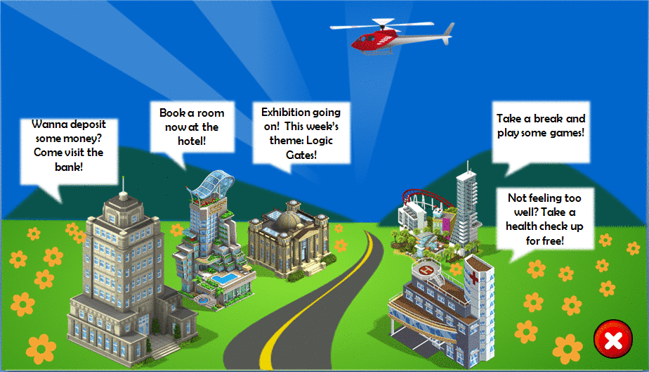The Smart City:
3. The Atlantis Hotel:

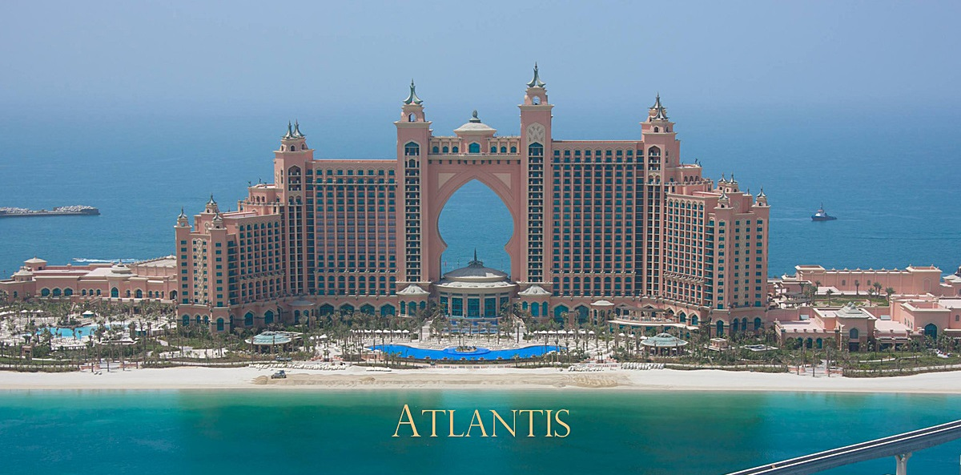

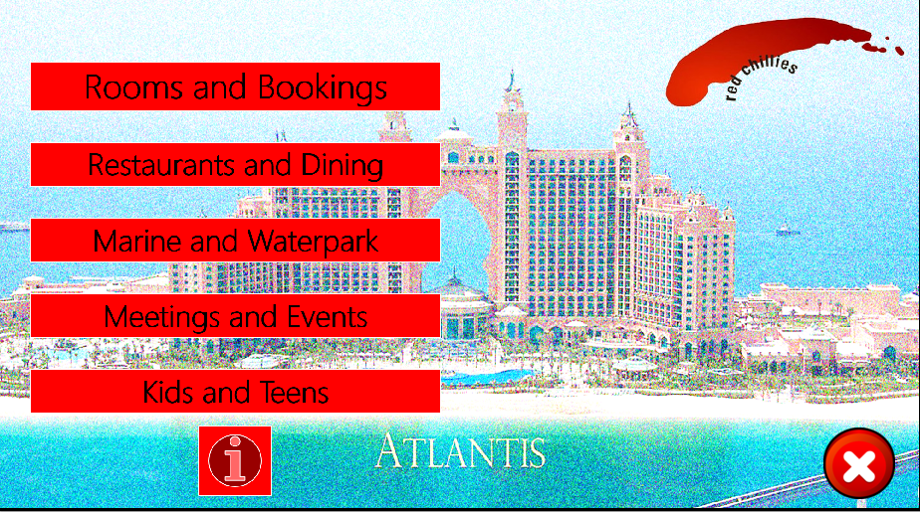

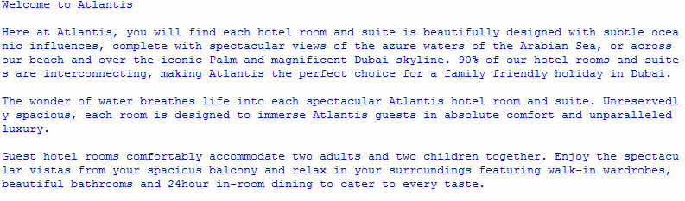

Rooms and Bookings

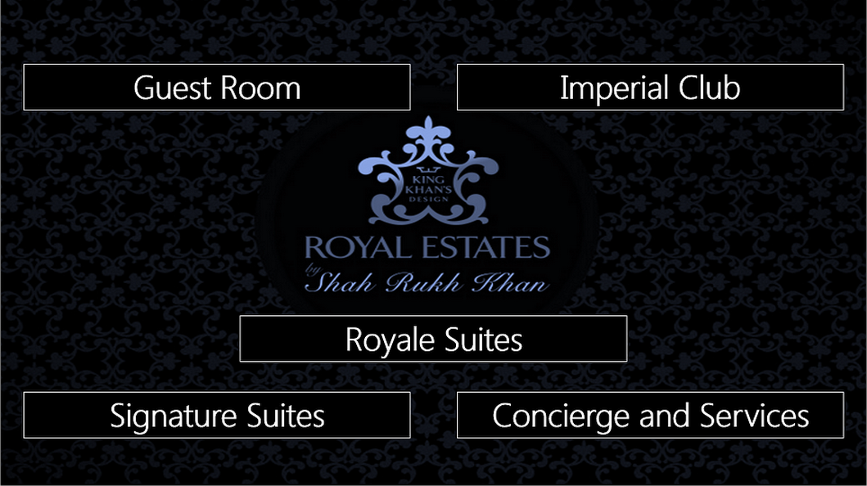

Guest Room

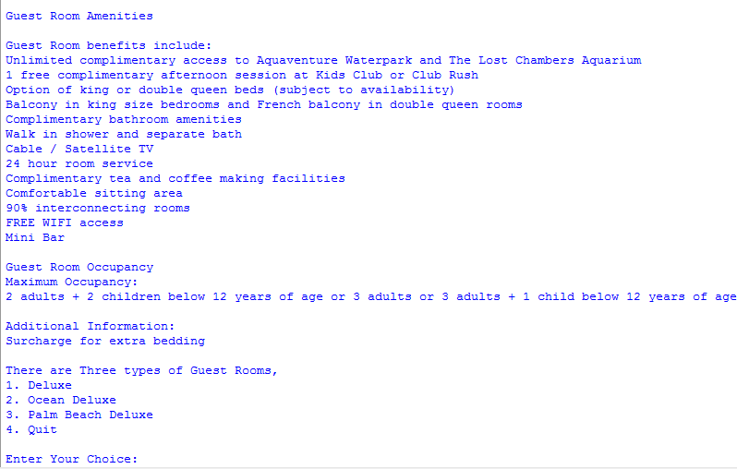

Example of Rooms

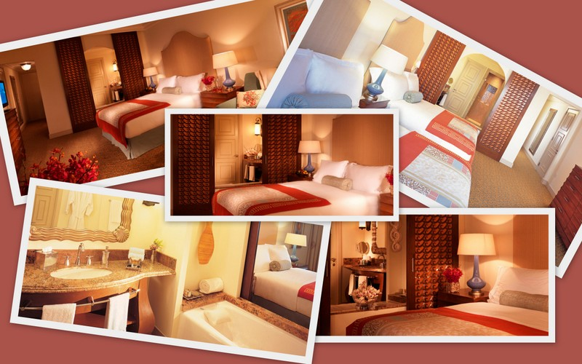

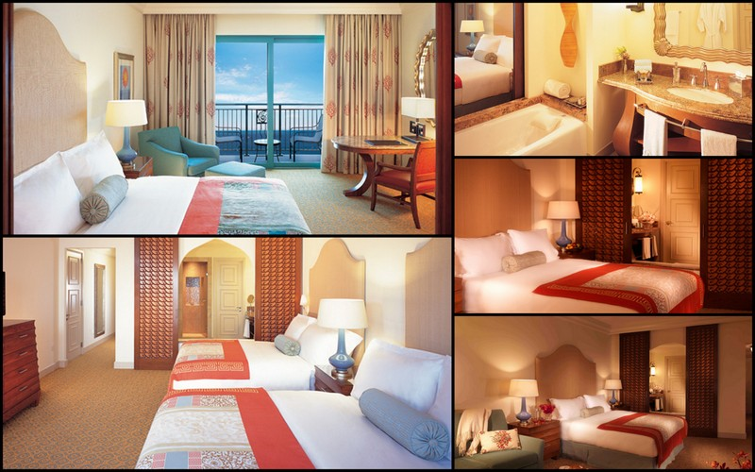

Choosing Rooms (For all)

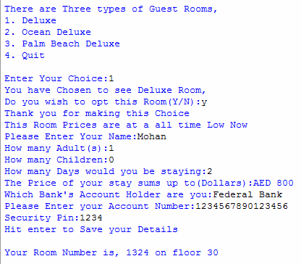

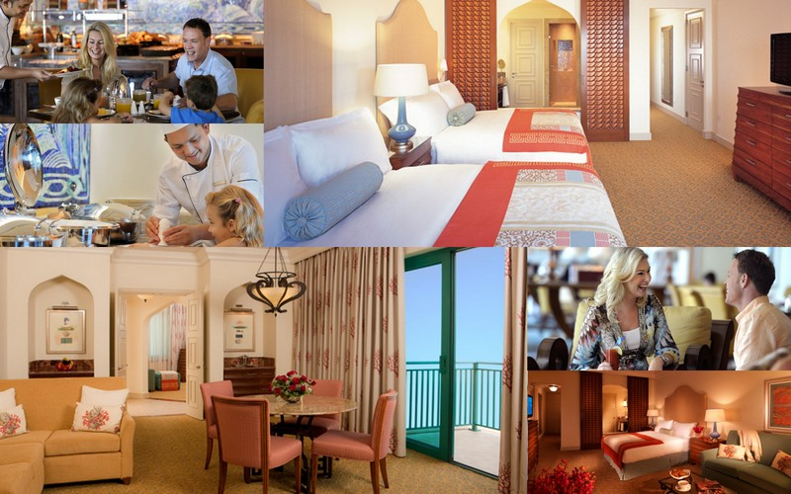Imperial Club

Royale Suites

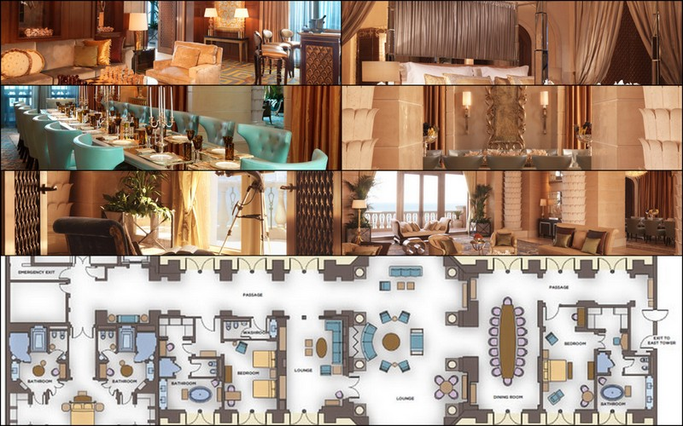

Signature Suites

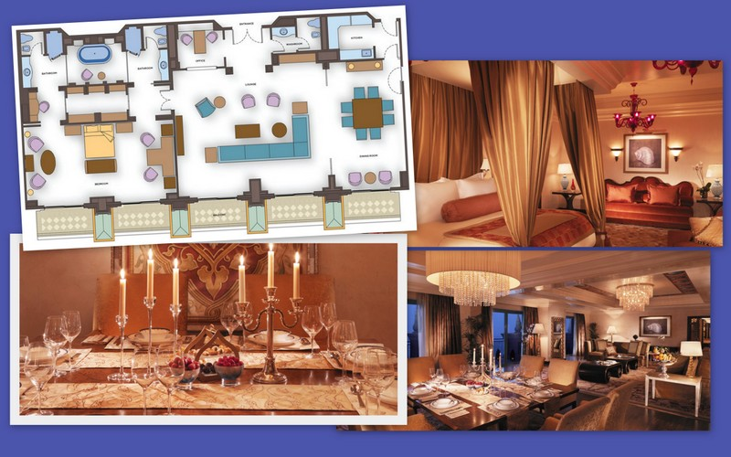

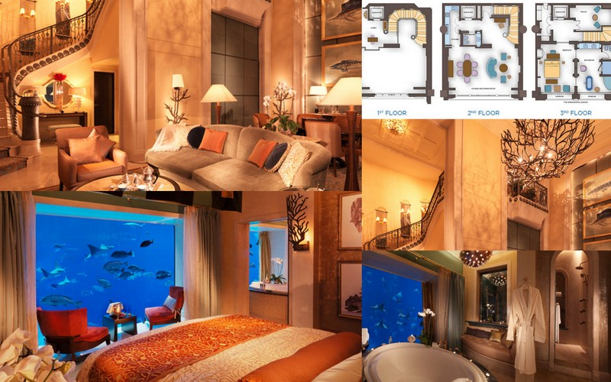

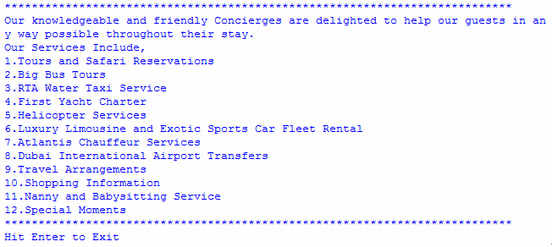Concierge and Services

Restaurants and Dining:

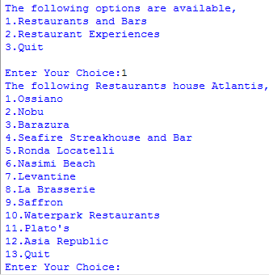

Restaurants and Bars

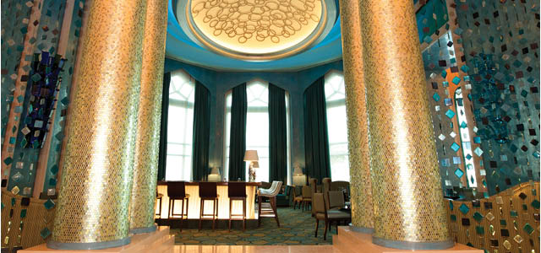

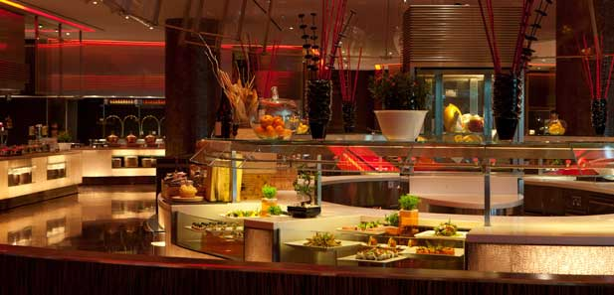

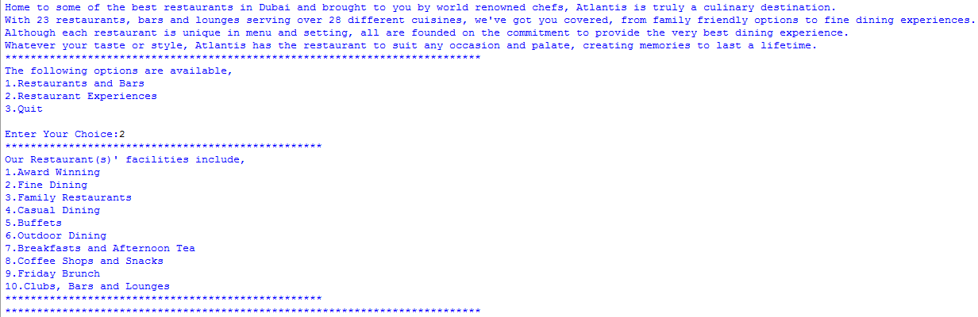Restaurant Experiences

Marine and Waterpark:

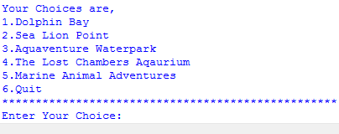

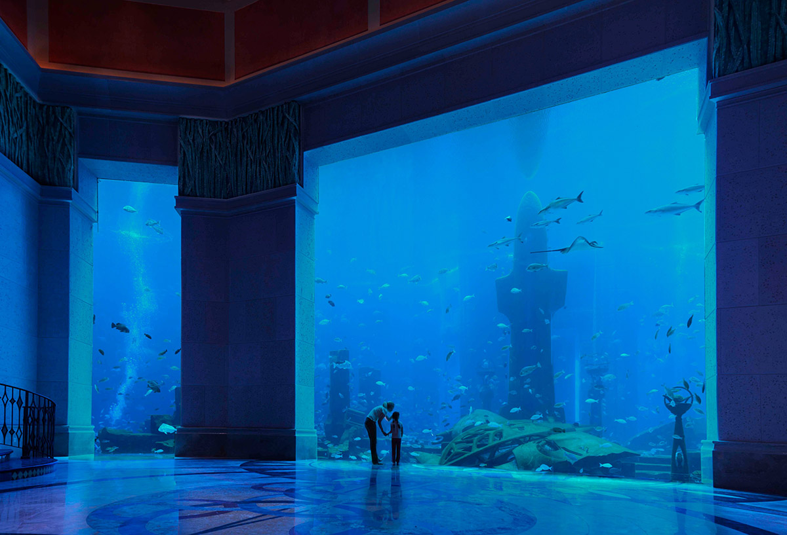

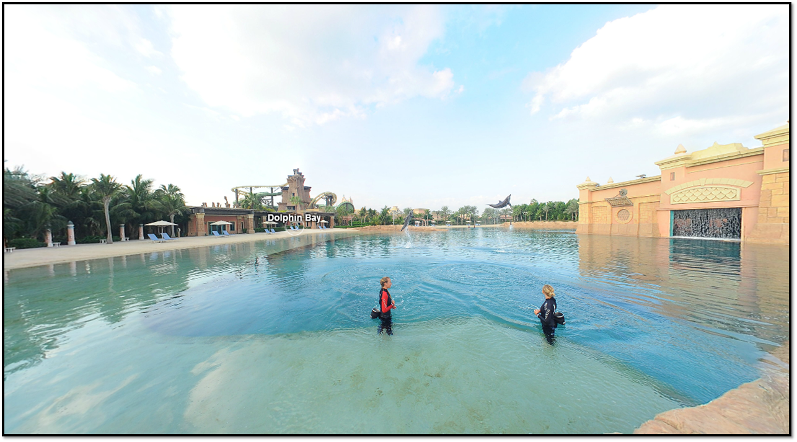

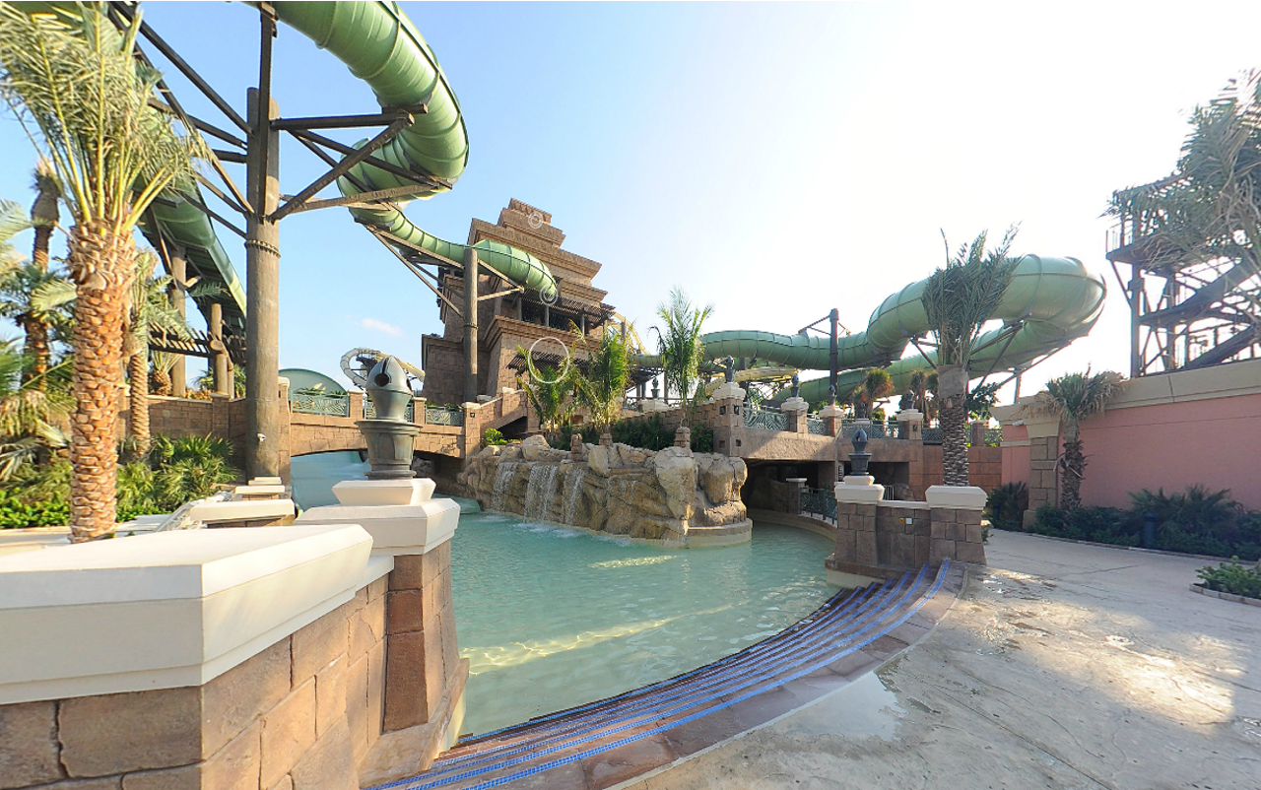

Meetings and Events:

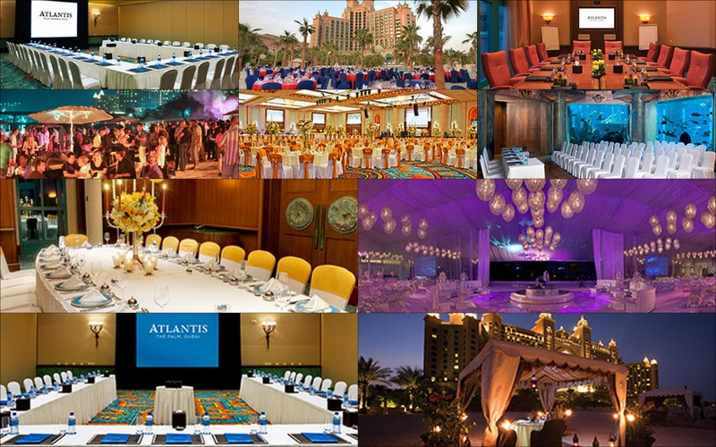

Kids and Teens:



Info



1. 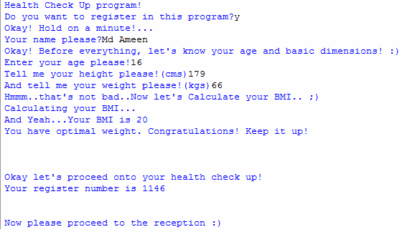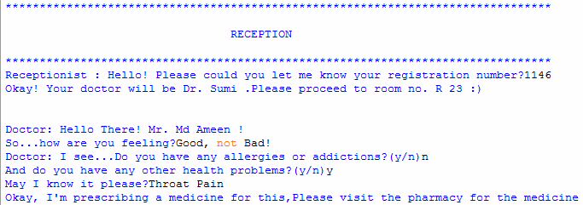The Virtual Hospital

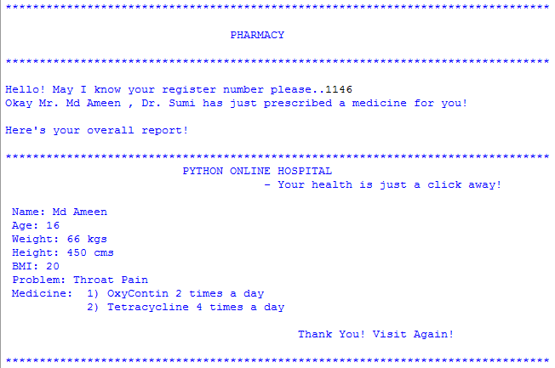





1. 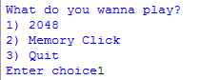Gaming Arena

2048

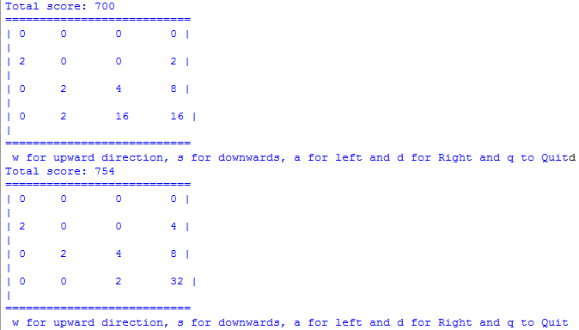

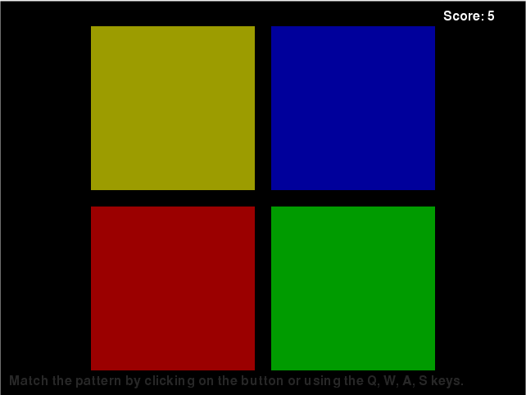Memory Click

1. Red Chillies International Bank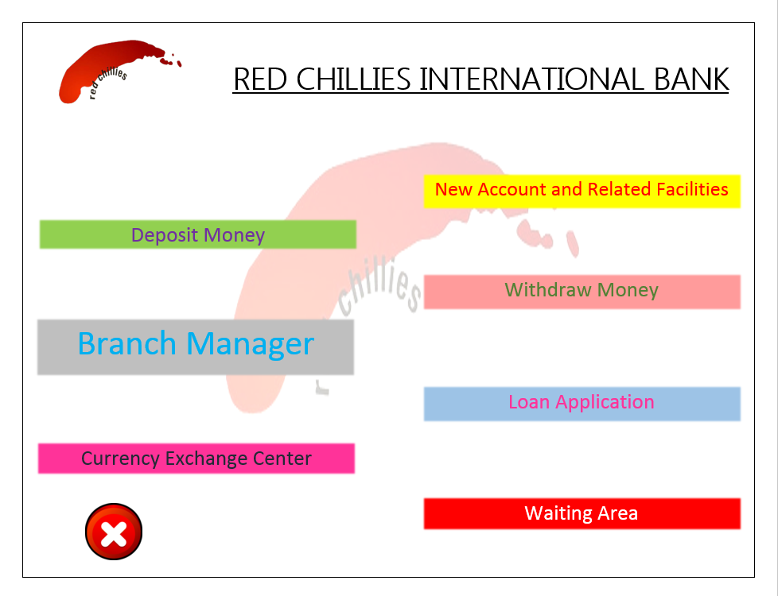

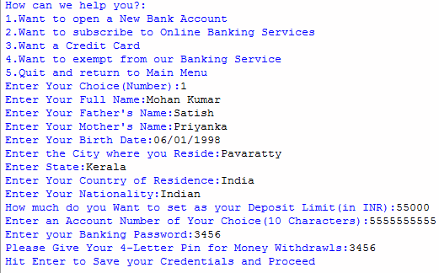

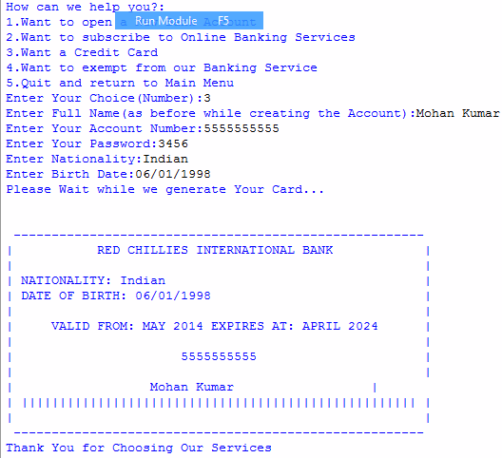

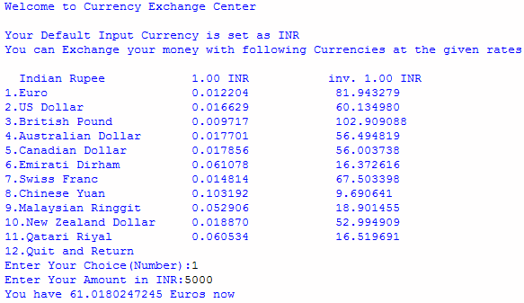

Depositing Money

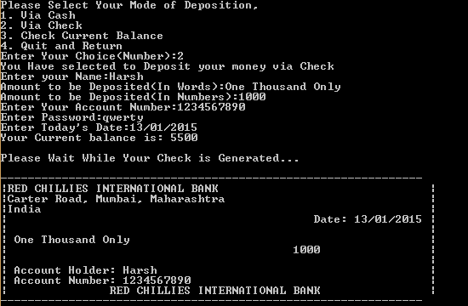

Withdrawing Money

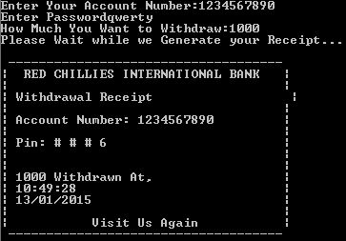

Loan Application

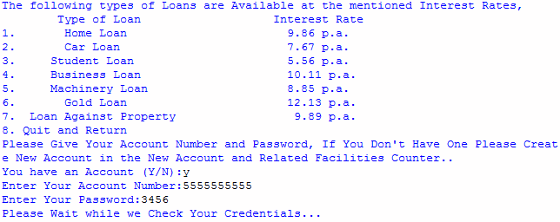

1. Exhibition Centre

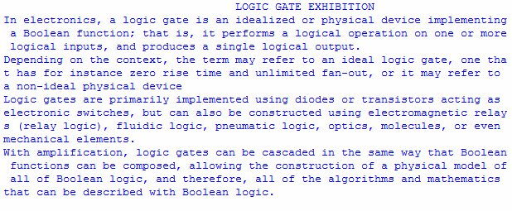

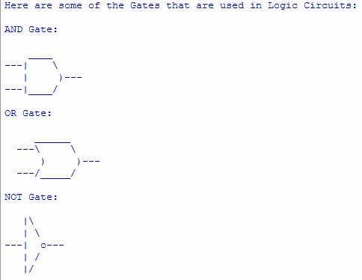

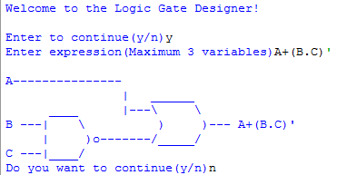

1. **Shortcomings**
2. Error Handling and Generator Functions are not included.
3. Everything is Virtual
4. Old Records of the Bank A/c holders need to be deleted manually.
5. It could be extended to encapsulate the realistic view of a City
6. **Bibliography**
7. Google
8. Stack Overflow
9. Python.org
10. Docs.python.org
11. Program Arcade Games
12. Wikipedia

THANK

YOU!